KWAME NKRUMAH UNIVERSITY OF SCIENCE AND TECHNOLOGY



FINAL YEAR PROJECT

Bsc. Computer Science

STUDENT ACADEMIA COPLIOT

BY:

ADU STEPHEN - 4187320

KESSEWAA ACHEAMPONG- 4184220

DR EMMANUEL AHENE

### DECLARATION

I declare without any reservation that we personally undertook this project, “STUDENT ACADEMIA COPILOT (**SAC AI)**” on KNUST campus, herein submitted under supervision.

Signed: Date:

___________________ ___________________

ADU STEPHEN

(4187320)

Signed: Date:

___________________ ___________________

KESSEWAA ACHEAMPONG

(4184220)

DECLARATION BY SUPERVISOR

I declare that I have personally supervised these students in undertaking the study report herein and I confirm that these students have my permission to present it for assessment.

Signed: Date:

_________________ ___________________

DR EMMANUEL AHENE

(SUPERVISOR)

ACKNOWLEDGEMENT

We would first and foremost like to thank God Almighty for His unending grace towards us for the completion of this work. We are also sincerely grateful to Dr Emmanuel Ahene, our supervisor and a lecturer of Computer Science Department, Kwame Nkrumah University of Science and Technology for his immense support and guidance. We acknowledge him for always making time for us each and every time to meet us, his constant support, advice and encouragement throughout this project. We express our profound gratitude to you.

### DEDICATION

We dedicate this project to our supervisor Dr Emmanuel Ahene and our wonderful parents for their love and every inspiration they gave us. We dedicate this project also to the students of Kwame Nkrumah University of Science and Technology.

Table of Contents

DECLARATION 2

DECLARATION BY SUPERVISOR 2

ACKNOWLEDGEMENT 3

DEDICATION 3

Chapter 1: Introduction 9

1.1 Problem Statement 9

1.2 Aim of Project 9

1.3 Specific Objectives 10

1.4 Justification of Project 12

1.5 Motivation of Project 13

1.6 Scope of Project 13

1.7 Project Limitation 14

1.8 Beneficiaries of Project 15

1.9 Academic and Practical Relevance of the Project 17

1.9.1 Academic Relevance 17

1.9.2 Practical Relevance 18

1.10 Project Activity Planning and Schedules 19

1.11 Structure of Report 20

1.12 Project Deliverables 24

Chapter 2: Review of Related Works / Review of Similar Systems 26

2.1 Processes of the Existing System 26

2.1.1 System Features 26

2.1.2 Advantages of Existing Related System (Quizlet) 27

2.1.3 Disadvantages of Existing Related System (Quizlet) 27

2.2 The Proposed System 28

2.3 Conceptual Design 29

2.4 Architecture of the Proposed System 29

2.5 Components Designs and Components Descriptions 32

2.5.1 User Interface 33

2.5.2 Authentication Service 34

2.5.3 Real-Time Database 35

2.5.4 Feedback System 36

2.5.5 Progress Tracking 36

2.6 Proposed System/Software Features 37

2.7 Development Tools and Environment 40

2.8 Benefits of Implementation of the Proposed System 41

Chapter 3: Methodology 43

3.1 Chapter Overview 43

3.2 Stakeholders of the System 43

3.3 Requirement Gathering Process 45

3.4 Functional Requirements 46

3.5 UML DIAGRAMS 48

3.5.1 Use Case Diagram 48

3.5.2 Activity Diagram 53

3.5.3 Sequence Diagram 55

3.5.4 Class Diagram 57

3.6 Non-Functional Requirements 60

3.7 Security Concepts 61

3.8 Project Methods 62

3.9 The Various Software Process Models 63

3.10 Project Model and Justification 65

3.10.1 Justification for Chosen Model 65

3.11 Project Design and Consideration 67

3.11.1 User Interface Design 67

3.10.2 Database Design 70

3.10.3 Development Tools 74

Chapter 4: Implementation and Results 77

4.1 Chapter Overview 77

4.2 Mapping Logical Design onto Physical Platform 77

4.2.1 Implementing the User Interface 78

4.2.2 Implementing the Database 80

4.3 Construction 82

4.4 Testing 87

4.4.1 Testing Plan 88

4.4.2 Components Testing 88

4.4.3 System Testing 91

4.5 Results 93

4.5.1 Component Testing Results 93

4.5.2 System Testing Results 94

4.5.3 User Feedback 94

4.5.4 Performance Metrics 94

Chapter 5: FINDINGS AND CONCLUSION 96

5.1 Chapter Overview 96

5.2 Findings 96

5.3 Conclusions 97

5.4 Challenges/Limitations of the System 97

5.5 Lessons Learnt 98

5.5.1 Technical Insights 98

5.5.2 Operational Insights 99

5.5.3 User Experience Insights 100

5.6 Recommendations for future works 101

5.6.1 Expanding the Question Bank 101

5.6.2 Enhancing User Features 102

5.6.3 Improving System Performance 102

5.7 Recommendations for Project Commercialization 103

5.7.1 Business Models 103

5.7.2 Marketing Strategies 104

5.7.3 Enhancing User Engagement 105

5.7.4 Monetization Opportunities 105

5.8 References 106

Table of Figures

Figure 1 - Diagram of Architecture of the Proposed System 27

Figure 2 - Use Case Diagram of System 46

Figure 3 - Activity Diagram 51

Figure 4 - Sequence Diagram 53

Figure 5 - Class Diagram 56

Figure 6 - Sign Up Page 65

Figure 7 - Login Page 65

Figure 8 - Colleges Page 65

Figure 9 - Programs Page 66

Figure 10 - Courses Page 66

Figure 11 - Start Test Page 66

Figure 12 - Test Page 66

Figure 13 - Score Page 66

Figure 14 - Review Answers Page 66

Figure 15 - Test History Page 67

Figure 16 - Profile Page 67

Figure 17 - About Page 67

Figure 18 - Entity Relationship Diagram 70

Figure 19 - Flowchart Diagram for Implementing the User Interface (UI) of the KNUST ExamMate 76

Figure 20 - Flowchart Diagram for Implementing the Database of the KNUST ExamMate System 78

Figure 21 - Code Snippet of Sign-up View 79

Figure 22 - Code Snippet of Colleges View 80

Figure 23 - Code Snippet of Profile View 81

Figure 24 - Code Snippet of Test View 82

Figure 25 - Code Snippet for Database Connect 83

Figure 26 - Code Snippet of Score View 84

# Chapter 1: Introduction

## 1.1 Problem Statement

Students today are inundated with information from a wide variety of sources, ranging from textbooks and academic journals to online articles and multimedia content. However, navigating and efficiently learning from these resources can be a daunting task. The challenge is further compounded when students need to extract meaningful insights or summaries from lengthy documents or complex web pages. Traditional study methods, which rely heavily on manual note-taking and self-summarization, are often inefficient and prone to errors. This lack of a centralized and intelligent tool to assist students in processing and understanding diverse forms of academic content results in fragmented learning experiences, reduced comprehension, and ultimately, diminished academic performance.

The "Student Academia Copilot" web application is designed to address these challenges by offering a comprehensive platform that enables students to learn from any document type or web page by simply providing a URL. This application aims to streamline the learning process by automatically analyzing, summarizing, and providing key insights from the provided content. By integrating advanced AI-driven features, the platform not only enhances comprehension but also saves students valuable time, allowing them to focus on applying their knowledge rather than merely gathering it. The user-friendly interface ensures that students can effortlessly navigate through the learning material, making the "Student Academia Copilot" an essential tool for academic success in the digital age.

## 1.2 Aim of Project

The aim of the "Student Academia Copilot" project is to develop an intelligent and user-friendly web application that empowers students to efficiently learn from any document type or web page by providing a URL. This application seeks to streamline the process of information extraction, comprehension, and application by leveraging advanced AI technologies to analyze, summarize, and present key insights from diverse academic resources. Ultimately, the project aspires to enhance students' learning experiences by providing them with a centralized platform that simplifies content navigation, improves understanding, and supports academic success across various subjects and disciplines.

## 1.3 Specific Objectives

The objectives of this project encompass designing an engaging user interface with Flutter, implementing precise timed practice tests, integrating secure Firebase authentication, creating a comprehensive feedback system, developing a scalable backend with Firebase, ensuring a smooth user experience, tracking test history, enabling test review functionality, optimizing performance, supporting multiple courses at KNUST, and conducting thorough testing and refinement.

* **Design and Craft a User Interface**:

Create an aesthetically pleasing and intuitive user interface using the Flutter framework, ensuring a seamless and engaging experience for users across all device types.

* **Integrate Firebase for User Authentication**:

Utilize Firebase for secure user authentication and robust data storage, ensuring the reliability and security of user profiles. This integration will provide a seamless login experience and protect user data.

* **Create a Comprehensive Feedback System**:

Establish a feedback system that offers insightful commentary on correct and incorrect answers, empowering users with a comprehensive understanding of their performance. This system will help students identify their strengths and areas for improvement.

* **Develop a Scalable Backend System**:

Develop a robust, scalable backend system using Firebase Realtime Database to efficiently store and categorize exam questions and their respective answers by course. This approach enables easy retrieval and organization of questions, ensuring a seamless experience for users as they access and practice questions relevant to their courses.

* **Ensure Smooth User Experience**:

Prioritize a smooth and delightful user experience with enhanced navigation features, allowing users to effortlessly move between sections, tests, and feedback screens. This includes intuitive navigation bars, easy access to different app sections, and quick transitions.

* **Optimize Performance and Responsiveness**:

Ensure that the application performs efficiently and responds quickly to user interactions, providing a smooth and lag-free experience. This includes optimizing loading times, minimizing app crashes, and ensuring compatibility across various devices.

* **Test and Refine the Application**:

Conduct thorough testing of the application to identify and fix any bugs or issues. Make necessary corrections to ensure the app functions smoothly and meets all user requirements. This includes beta testing with real users and iterating on feedback to enhance the app's performance and user satisfaction.

## 1.4 Justification of Project

The "Student Academia Copilot" project is justified by the growing need for innovative educational tools that cater to the diverse and evolving learning preferences of students. In an age where information is abundant but often overwhelming, students require efficient ways to access, comprehend, and retain knowledge from a wide array of resources, including digital documents and web pages. Traditional learning methods, while still valuable, often fall short in addressing the dynamic and immediate needs of modern students who seek quick, reliable, and personalized content.

Moreover, the increasing complexity of academic materials and the widespread availability of online resources necessitate a tool that can effectively filter, summarize, and present information in a digestible format. The "Student Academia Copilot" aims to fill this gap by providing an AI-powered solution that not only facilitates learning but also empowers students to independently explore and understand complex topics.

This project is further justified by its potential to democratize access to quality education. By enabling students to learn from a broad spectrum of document types and web pages, regardless of their geographical location or socioeconomic background, the "Student Academia Copilot" can help bridge the educational divide. The project's focus on usability and adaptability ensures that it can be a valuable resource for students at all levels, from primary education to higher learning, thereby contributing to more equitable and inclusive education opportunities.

## 1.5 Motivation of Project

The motivation behind the "Student Academia Copilot" project stems from the recognition of the challenges students face in navigating and learning from the vast array of digital content available today. As education increasingly shifts towards digital platforms, students are inundated with information from various sources, including academic journals, e-books, research papers, and web pages. However, the lack of tools that can seamlessly integrate and simplify these resources into coherent learning experiences often leads to confusion, inefficiency, and missed learning opportunities.

Another key motivator is the desire to leverage advancements in artificial intelligence to enhance educational outcomes. AI has the potential to transform the way students interact with information by providing personalized learning experiences that cater to individual needs and learning styles. The "Student Academia Copilot" aims to harness this potential, offering a tool that can analyze and summarize complex documents, highlight key concepts, and provide interactive learning experiences, all in real-time.

Additionally, the project is driven by a commitment to making learning more accessible and efficient. Many students struggle to find reliable resources and often spend more time searching for information than learning it. By providing a centralized platform where students can input a URL and instantly gain insights and understanding from the content, the "Student Academia Copilot" seeks to reduce the barriers to effective learning, save time, and ultimately enhance academic performance.

This motivation is further fueled by the desire to contribute to the broader goal of educational equity. In many parts of the world, students do not have access to high-quality educational materials or personalized learning support. The "Student Academia Copilot" project aspires to bridge this gap by offering a tool that is not only powerful and versatile but also accessible to students from diverse backgrounds, helping to level the playing field in education.

## 1.6 Scope of Project

The Student Academia Copilot project aims to develop an innovative web application designed to assist students in learning from various document types through a chat-based AI model. The application will serve as an interactive learning tool, enabling students to upload documents and engage with AI-driven insights and explanations.

- User Interface and Experience:

- Develop an intuitive, user-friendly interface using React, ensuring easy navigation and seamless interaction with the AI model.

- Functionality:

- Implement a document upload feature that supports multiple file types, allowing users to submit study materials, notes, or other educational documents.

- Develop an interactive chat model where users can ask questions and receive explanations, summaries, and insights from the AI model (e.g., GPT-3.5).

- Backend Development:

- Create a robust backend system to handle document processing and interaction with the AI model, ensuring efficient and accurate responses.

- Use Firebase Realtime Database to manage user data, document uploads, and session history securely.

- Integration:

- Integrate OpenAI’s GPT-3.5 or similar models for processing and generating responses to user queries based on the uploaded documents.

- Compatibility:

- Ensure the application is responsive and accessible across various devices, including desktops, tablets, and smartphones.

- Version Control:

- Use Git for version control to maintain a clear and well-documented development history, facilitating collaboration and tracking of changes.

- Testing:

- Conduct comprehensive testing for functionality, performance, and accuracy, ensuring the AI model provides helpful and relevant information.

- Perform user acceptance testing to ensure the application meets educational needs and user expectations.

- Educational Impact:

- Empower students with features like interactive Q&A, document summarization, and personalized learning suggestions based on their interactions with the AI model.

- Documentation:

- Maintain thorough project documentation covering all aspects of development, from system architecture to user guides.

- Stakeholder Engagement:

- Collect feedback from users and educational stakeholders to drive continuous improvement and ensure the application remains relevant and effective in meeting students' learning needs.

## 1.7 Project Limitation

Despite the innovative approach and extensive features of the Student Academia Copilot project, there are certain limitations to consider:

- AI Model Limitations:

- The accuracy and relevance of the responses generated by the AI model (e.g., GPT-3.5) are dependent on the quality and clarity of the uploaded documents. The model may struggle with poorly formatted or complex academic materials, leading to less effective learning outcomes.

- File Type and Size Constraints:

- While the application aims to support a wide range of document types, there may be limitations on the maximum file size and certain file formats that the AI model can effectively process, potentially restricting the range of materials users can upload.

- Contextual Understanding:

- The AI model may lack deep contextual understanding of certain specialized subjects or topics, resulting in generic or incomplete explanations, which may not fully satisfy the educational needs of advanced users.

- Internet Dependency:

- The application requires a stable internet connection for real-time interaction with the AI model. Users in areas with limited or unreliable internet access may experience interruptions or delays in receiving responses.

- Privacy and Security Concerns:

- Despite implementing secure data storage practices, there is always a risk of data breaches or unauthorized access, particularly when handling sensitive academic materials. Ensuring absolute privacy cannot be fully guaranteed.

- Cost of AI Usage:

- The reliance on third-party AI services (such as OpenAI) may incur ongoing costs, which could limit the scalability of the application, especially if usage increases significantly over time.

- Learning Style Limitations:

- The application primarily caters to students who prefer interactive, AI-driven learning. It may not be as effective for those who benefit more from traditional study methods or human-led instruction.

- Customization Challenges:

- While the AI model can provide general learning support, it may lack the ability to tailor feedback and guidance to individual learning preferences or specific academic curricula.

These limitations highlight areas where the project might face challenges, but also provide opportunities for future improvements and enhancements.

## 1.8 Beneficiaries of Project

The Student Academia Copilot project is designed to serve a wide array of stakeholders, each benefiting uniquely from the application’s innovative features and capabilities.

- University Students:

- University students are the primary beneficiaries of the Student Academia Copilot. The application offers a dynamic and interactive way for students to engage with their study materials. By uploading documents and receiving AI-driven explanations, summaries, and insights, students can enhance their understanding of complex topics. The personalized learning support provided by the AI model helps students identify areas where they need improvement and offers targeted assistance, making study sessions more efficient and effective. The application’s accessibility ensures that students can study anytime, anywhere, making learning more flexible and adaptable to their needs.

- Academic Institutions:

- Academic institutions stand to benefit significantly from the Student Academia Copilot as it provides an additional learning resource that complements traditional teaching methods. By incorporating the app into their academic support systems, institutions can offer students a tool that aids in self-directed learning and improves academic performance. The app can also provide institutions with insights into student engagement and learning trends, helping to identify areas where further academic support may be required.

- Educators and Tutors:

- Educators and tutors can leverage the Student Academia Copilot as a valuable resource to supplement classroom instruction. The app allows educators to assign additional reading materials and track how well students understand the content through AI-driven feedback. This feedback helps educators identify common challenges students face and adjust their teaching methods accordingly. Tutors can also use the app to monitor their students' progress and provide personalized guidance, enhancing the overall learning experience.

- Parents and Guardians:

- Parents and guardians benefit from the Student Academia Copilot by gaining better insights into their child’s academic progress and learning habits. The app provides a supportive tool that enables parents to assist their children in their studies, offering encouragement and additional resources as needed. By understanding their child’s strengths and areas for improvement, parents can play a more active role in their child’s education, fostering a collaborative approach to academic success.

- Prospective Students:

- Prospective students can use the Student Academia Copilot to get a head start on their university studies by familiarizing themselves with the types of academic materials they will encounter. The app helps prospective students build confidence and gain a better understanding of university-level content, making their transition to higher education smoother and less daunting.

- Developers and Tech Community:

- The development of the Student Academia Copilot also benefits developers and the broader tech community by showcasing the potential of AI in educational technology. The project serves as a case study for integrating advanced AI models like GPT-3.5 into learning platforms, inspiring further innovation in the EdTech space. Developers working on the project can refine their skills in AI integration, user experience design, and web application development. Additionally, the project highlights the role of technology in addressing educational challenges, promoting a culture of innovation and continuous improvement within the tech community.

By catering to the needs of these diverse beneficiaries, the Student Academia Copilot aims to make a meaningful impact on the educational landscape, promoting a culture of personalized learning and continuous academic improvement.

## 1.9 Academic and Practical Relevance of the Project

The Student Academia Copilot project is highly relevant both academically and practically, contributing to the advancement of education through innovative technology and offering tangible benefits to students, educators, and the broader academic community.

1.9.1 Academic Relevance

The Student Academia Copilot project plays a crucial role in enhancing learning experiences, supporting personalized education, supplementing traditional learning methods, and providing valuable data for educational research, thereby fostering a comprehensive and effective learning environment for students.

- **Enhanced Learning Outcomes:**

- By providing an interactive platform where students can upload documents and receive AI-driven explanations, the Student Academia Copilot directly contributes to improved learning outcomes. The AI model helps students understand complex topics, identify areas where they need more focus, and engage in active learning. This personalized approach to learning enhances comprehension and retention of course material.

- **Support for Personalized Learning:**

- The application empowers students to take control of their learning by allowing them to interact with the AI model at their own pace. Students can ask questions, request summaries, and explore content based on their individual needs and preferences. This self-directed learning approach is critical for developing critical thinking and problem-solving skills, which are essential for academic success.

- **Supplement to Traditional Education:**

-The Student Academia Copilot serves as a valuable supplement to traditional classroom instruction. It provides additional resources for review and exploration, complementing the curriculum delivered by educators. This holistic approach to learning ensures that students have multiple ways to engage with and master their course content.

- **Research and Data Collection:**

- The app's interaction data can be leveraged for educational research. Insights into how students engage with content, the types of questions they ask, and the topics they find challenging can inform curriculum development and teaching strategies. Educators and researchers can use this data to identify effective educational practices and create targeted interventions to support student learning.

1.9.2 Practical Relevance

The practical relevance of the Student Academia Copilot project lies in its ability to provide accessible, convenient, and scalable learning resources, integrate advanced technology into education, and promote continuous learning, thereby addressing key challenges faced by students and educational institutions.

- **Accessibility and Convenience:**

- The Student Academia Copilot addresses the practical challenge of accessing personalized study assistance. By allowing students to upload documents and receive immediate, AI-generated feedback, the app makes learning more accessible and convenient, regardless of time or location. This is particularly beneficial for students with diverse learning schedules and those who may not have easy access to traditional study resources.

- **Technological Integration in Education:**

-The project exemplifies the integration of cutting-edge technology in education, showcasing the potential of AI to transform learning experiences. By utilizing AI models like GPT-3.5, the app demonstrates how modern technology can be harnessed to create effective and user-friendly educational tools that adapt to the needs of individual learners.

- **Scalability and Flexibility:**

-The use of scalable backend technologies ensures that the Student Academia Copilot can accommodate a growing number of users and a wide range of academic content. This scalability is crucial for supporting a large and diverse student population and potentially expanding to other educational institutions. The flexible design of the app allows for easy updates and the addition of new features, ensuring that it can evolve to meet changing educational demands.

- **Promotion of Lifelong Learning:**

- The Student Academia Copilot promotes a culture of lifelong learning by providing a continuous platform for knowledge enhancement. Students, alumni, and other users can use the app to stay updated on academic skills and engage in ongoing learning activities. This commitment to continuous education supports personal and professional growth, helping users adapt to the evolving demands of their academic and career paths.

By addressing these academic and practical considerations, the Student Academia Copilot project aims to make a significant impact on the educational landscape, fostering a more personalized, efficient, and accessible learning experience for students.

## 1.10 Project Deliverables

The deliverables of the Student Academia Copilot project are as follows:

- **A fully functional web application:**

- Developed using React, the web application will allow users to upload various document types and interact with an AI model like GPT-3.5 for personalized learning support.

- **Document upload and processing features:**

- Implementation of a robust document upload system that supports multiple file types, enabling users to submit study materials for AI-driven analysis and insights.

- **AI-driven chat model:**

-Integration of a chat interface where users can engage with the AI to ask questions, receive explanations, summaries, and other forms of academic assistance based on the uploaded documents.

- **Seamless integration with Firebase:**

- Secure user authentication, session management, and data storage using Firebase, ensuring the reliability and security of user data and interactions.

- **Scalable backend system:**

- Development of a scalable backend system to efficiently handle document processing, AI interactions, and user data management, ensuring the application can support a growing number of users.

- **Intuitive user interface:**

- Design and implementation of an aesthetically pleasing and user-friendly interface that prioritizes user experience, with enhanced navigation features for easy interaction with the AI model.

- **Performance tracking features:**

-Implementation of features that allow users to track their learning progress, view interaction history, and monitor improvements over time.

- **Cross-device compatibility:**

- Ensuring the web application is responsive and compatible with various devices, including desktops, tablets, and smartphones, providing a seamless experience across platforms.

-**Rigorous testing:**

-Comprehensive testing of the application for functionality, accuracy, and user satisfaction to ensure its effectiveness and reliability in supporting student learning.

- **Version control using Git:**

- Utilization of Git for version control, maintaining a well-documented version history and facilitating collaborative development, ensuring smooth updates and feature additions.

# Chapter 2: Review of Related Works / Review of Similar Systems

In this chapter, we will review existing mobile test-taking applications, with a specific focus on Quizlet, a popular study tool used by students and educators. The chapter will explore the features, advantages, and limitations of Quizlet, followed by an introduction to the proposed system, its conceptual design, architectural framework, component descriptions, and development environment. This analysis will set the foundation for understanding the improvements and benefits offered by the proposed mobile app for test-taking.

## 2.1 Processes of the Existing System

In this section, we will provide a comprehensive review of Quizlet, a popular mobile test-taking and study application widely used by students and educators. This review will include an in-depth look at the features that make Quizlet a valuable tool for studying and test preparation. We will also analyze the advantages and disadvantages of Quizlet to understand its effectiveness and identify areas where it could be improved.

### 2.1.1 System Features

Quizlet offers a range of features that cater to various aspects of the learning and assessment process, making it an invaluable tool for studying and test preparation. The key features of Quizlet include:

* Flashcard Sets: Allows users to create, share, and study flashcard sets. Users can include text, images, and audio in their flashcards, enhancing the learning experience.
* Quizzes and Tests: Users can take quizzes and tests based on their flashcard sets. The app provides different test formats such as multiple-choice, true/false, and written questions.
* Learning Games: Quizlet offers engaging learning games like Match and Gravity, which make studying more interactive and enjoyable.
* Study Modes: The app includes various study modes like Learn, Write, and Spell, which help users reinforce their knowledge through repetition and different types of engagement.
* Progress Tracking: Quizlet tracks users' progress and provides detailed feedback on their performance, helping them identify areas for improvement.
* Collaboration: Users can collaborate with classmates and teachers by sharing flashcard sets and joining study groups.

### 2.1.2 Advantages of Existing Related System (Quizlet)

Quizlet provides several compelling advantages, including:

* Accessibility: Quizlet is available on multiple platforms, including iOS, Android, and web browsers, making it easily accessible to a wide audience. Users can study anytime and anywhere.
* User-friendly Interface: Quizlet features an intuitive and engaging interface that enhances the user experience. The app is easy to navigate, even for first-time users.
* Wide Range of Study Materials: Quizlet supports various subjects and allows users to find or create content that suits their needs. The extensive library of user-generated flashcard sets covers a vast array of topics.
* Real-time Feedback and Progress Tracking: Quizlet provides instant feedback on quizzes and tests, along with detailed progress tracking to help users identify areas for improvement. The app's analytics help users monitor their study habits and achievements.
* Interactive Learning Tools: The app's learning games and study modes make studying more engaging and effective. These tools help users retain information better by offering different ways to interact with the material.

### 2.1.3 Disadvantages of Existing Related System (Quizlet)

Despite its strengths, Quizlet has several notable disadvantages including:

* **Limited to Predefined Questions and Tests:**

Users are often restricted to the content available within the app, which may not cover all necessary topics or align with specific curriculum requirements. While users can create their own content, it requires additional time and effort.

* **Lack of Advanced Customization Options:**

Customization features for creating personalized tests and adjusting test settings are often limited. Users may find it challenging to tailor their study sessions to their specific needs.

* **Potential Privacy and Security Concerns:**

Handling sensitive user data can be a challenge, and some apps, including Quizlet, may not implement robust security measures. There is always a risk of data breaches or unauthorized access to user information.

* **Dependence on Internet Connectivity:**

While Quizlet offers an offline mode, many features still require a constant internet connection. This can be a limitation for users with unreliable access to the internet or those who prefer to study offline.

## 2.2 The Proposed System

The proposed mobile application is designed to revolutionize the test-taking experience for students by providing a flexible and secure platform for timed trial tests on various courses offered by KNUST. This section offers a comprehensive overview of the proposed system, detailing its objectives, innovative features, high-level architecture, and enhanced user experience. The proposed app aims to become an indispensable tool for people in their academic journey.

The app will offer a wide range of test subjects and formats, aligning closely with university curricula to cater to diverse academic needs. Its user-friendly interface will be designed to make the test-taking process intuitive and engaging, while robust security measures will ensure that user data is always protected.

In addition to these features. Real-time feedback and progress tracking will help users monitor their performance and identify areas for improvement. The high-level architecture of the app will be designed to support seamless operation and scalability, ensuring a smooth and reliable user experience.

By leveraging the latest technologies and best practices in mobile app development, the proposed system aims to set a new standard in the realm of educational applications, making test preparation more accessible, efficient, and effective for students.

## 2.3 Conceptual Design

The conceptual design phase for the KNUST ExamMate project outlines the fundamental structure and major components of the proposed mobile application, ensuring a clear understanding of its functionality and design rationale. The client-server architecture involves a mobile app developed using Flutter, interacting with backend services provided by Firebase, including the user interface, authentication service, real-time database, and feedback and progress tracking systems. Key components include a user-friendly interface for registration, login, test-taking, feedback, and progress tracking; Firebase Authentication for secure user management; a real-time database for data synchronization; a feedback system for immediate results; and test history for progress tracking and performance analytics. The application features timed practice tests, instant feedback, and a comprehensive question bank, all developed using tools like Flutter, Firebase, Dart, Android Studio, Git, and GitHub. The benefits include enhanced study preparation, immediate feedback, flexible access, data-driven insights, and secure, scalable data management.

## 2.4 Architecture of the Proposed System

The following diagram illustrates the high-level architecture of the KNUST ExamMate application, showcasing the interactions between the client application, user interface, Firebase services, and various system components.

Figure 1 - Diagram of Architecture of the Proposed System

The architecture of the KNUST ExamMate application is designed to ensure scalability, flexibility, and ease of maintenance. The system follows a client-server model, where the client application interacts with various Firebase services to provide a seamless and efficient user experience. The major components of the system include the user interface, authentication service, real-time database, feedback system, and progress tracking, all orchestrated through Firebase services.

* **Client Application:**

The client application, used by students, is the front-end interface where all interactions occur. It includes various functionalities such as user registration, login, taking practice tests, receiving feedback, and tracking progress.

* **User Interface:**

The user interface (UI) is a crucial component that handles user interactions. It provides a visually appealing and user-friendly experience, allowing users to navigate through different features of the application smoothly. The UI interacts with Firebase services to fetch and display data in real-time.

* **Firebase Services**

Firebase services form the backbone of the application's backend infrastructure. These services include authentication, real-time database, and analytics, each serving specific roles to ensure the application operates efficiently.

* Authentication Service: This service manages user authentication, handling user sign-up, login, and secure management of user credentials. It ensures that only authorized users can access the application’s features.
* Real-Time Database: The real-time database stores all the exam questions, user profiles, test results, and progress data. It ensures real-time data synchronization, so any updates made by the user are immediately reflected across the application.
* Analytics Service: This service provides analytics capabilities, tracking user performance and storing test results to help monitor and analyze user progress over time.
* **Feedback System**

The feedback system is an essential component that interacts with both the user interface and the authentication service. It provides immediate results after each test, highlighting correct and incorrect answers along with explanations. This system helps users identify their strengths and areas for improvement.

* **Progress Tracking**

The progress tracking component interacts with the analytics service to monitor and store user performance data. It provides insights into users' study habits and progress, allowing them to view their test history and receive performance analytics. This helps users focus on areas needing improvement and track their progress over time.

* **Data Flow and Interaction**
* The client application uses the user interface to interact with Firebase services.
* The user interface interacts with the authentication service for user login and sign-up processes.
* The real-time database handles user authentication data, user data, and test results, providing a seamless data flow between the UI and backend.
* The feedback system interacts with the UI and the authentication service to provide immediate test results to users.
* The progress tracking component monitors user performance, storing data in the analytics service and providing insights through the UI.

This architecture ensures that the KNUST ExamMate application is robust, scalable, and capable of providing a seamless and efficient exam preparation experience for students. The use of Firebase services for backend operations ensures real-time data synchronization, secure user authentication, and comprehensive performance tracking, all crucial for the application's success.

## 2.5 Components Designs and Components Descriptions

The KNUST ExamMate system comprises several integral components that work together to provide a seamless and efficient exam preparation experience. Below is a list of the individual components, each playing a crucial role in the overall system architecture:

* User Interface (UI)
* Authentication Service
* Real-Time Database
* Feedback System
* Progress Tracking

Each of these components is designed to enhance the functionality and user experience of the KNUST ExamMate system. The following sections will detail the design and functionality of each component, illustrating how they contribute to the overall system architecture.

### 2.5.1 User Interface

The user interface (UI) is the primary interaction point for users, designed to be intuitive and user-friendly to ensure an engaging experience. It encompasses several key screens and functionalities, each playing a crucial role in providing a seamless and efficient user experience.

* The Registration and Login Screens are essential for user onboarding and secure access to the application. These screens allow students to create accounts and log in securely. During registration, user details are captured and stored in the Firebase Realtime Database, ensuring that the data is readily available for future interactions. The login functionality verifies user credentials using Firebase Authentication, ensuring secure access and protection of user data. A flowchart depicting the registration and login process helps to visualize this workflow.
* The Home Screen serves as the main dashboard for navigating the application's features. It provides users with easy access to practice tests, feedback, and progress tracking. Additionally, the home screen displays relevant notifications and summaries of user activity, keeping users informed about their performance and upcoming tasks. A wireframe of the home screen layout provides a clear visual representation of its design and functionality.
* The Practice Test Screen is designed to allow users to select and take practice tests. Users can choose subjects and topics, initiate tests, and respond to questions within a timed environment. The UI dynamically updates to show the remaining time and allows the submission of answers, ensuring that the test-taking experience closely simulates real exam conditions. A screen layout diagram of the practice test interface illustrates how these elements are organized.
* The Feedback Screen is crucial for providing detailed feedback after test completion. This screen shows correct and incorrect answers, provides explanations, and highlights areas for improvement based on user performance. The feedback helps users understand their mistakes and focus on areas needing improvement. A screen layout showing the feedback interface offers a visual guide to this functionality.
* The Progress Tracking Screen enables users to monitor their performance over time. This screen displays a history of tests taken and scores, helping users track their progress and adjust their study strategies accordingly. By providing insights into their learning journey, the progress tracking screen motivates users to improve continuously. A screen layout showing the progress tracking interface provides a visual representation of this feature.

### 2.5.2 Authentication Service

The authentication service is a critical component of the KNUST ExamMate system, ensuring secure user access and data management. It leverages Firebase Authentication to manage the entire process of user sign-up, login, and secure credential handling.

* Firebase Authentication plays a pivotal role in managing user identities within the application. It is responsible for handling the sign-up and login processes, ensuring that only authorized users can access the system's features. During the sign-up process, Firebase Authentication captures and securely stores user credentials. This ensures that each user’s data is protected from unauthorized access and potential security breaches.
* The primary functionality of Firebase Authentication is to verify user identities. When a user attempts to log in, the authentication service checks the provided credentials against the stored data to confirm the user's identity. This verification process is crucial for maintaining the integrity and security of the system. By ensuring that only authenticated users can access the application, Firebase Authentication helps protect sensitive data and prevents unauthorized usage.
* Furthermore, Firebase Authentication securely manages and stores authentication data. This includes encrypting passwords and other sensitive information, ensuring that user credentials are not exposed to potential threats. By leveraging Firebase’s robust security protocols, the KNUST ExamMate system ensures that user data is safeguarded, providing a secure environment for students to engage with the application.

### 2.5.3 Real-Time Database

The real-time database is the backbone of the KNUST ExamMate system, playing a crucial role in storing all critical data and ensuring real-time synchronization. This component leverages Firebase Realtime Database to manage data efficiently, providing a seamless and responsive user experience.

* Firebase Realtime Database is integral to the system, handling the storage and management of essential data such as user profiles, exam questions, test results, and progress tracking information. This database supports real-time data updates, ensuring that any changes made by users are immediately reflected across the application. This feature is vital for maintaining consistency and accuracy of the data, allowing users to always access the most current information.
* The primary functionality of the Firebase Realtime Database is to manage data storage and retrieval processes. It supports CRUD (Create, Read, Update, Delete) operations, enabling the application to efficiently handle various data management tasks. For instance, when a user registers, their details are stored in the database; when they take a test, their results are updated in real-time; and when they track their progress, the database retrieves and displays the relevant data. This continuous interaction ensures that the application remains dynamic and responsive to user inputs.
* Furthermore, the database organizes data in a structured manner, categorizing exam questions by course and topic. This organization facilitates easy retrieval and efficient management of the data, allowing users to quickly find and access the information they need. The real-time synchronization feature ensures that any updates or modifications are instantly propagated throughout the system, providing a consistent experience for all users.
* In addition to data management, the Firebase Realtime Database also supports secure data storage. It implements robust security measures to protect user data from unauthorized access and potential breaches. By encrypting data and enforcing access controls, the database ensures that sensitive information remains confidential and secure.

### 2.5.4 Feedback System

The feedback system is an essential component of the KNUST ExamMate system, providing immediate and detailed feedback to users after each test. This component plays a crucial role in helping students understand their performance, identify areas for improvement, and enhance their learning experience.

* The primary function of the feedback system is to deliver performance feedback to users as soon as they complete a test. This immediate response is critical for effective learning, as it allows students to quickly understand their mistakes and correct them while the information is still fresh in their minds. By offering real-time feedback, the system ensures that users receive timely and relevant information that can aid in their study efforts.
* The feedback system operates by analyzing the test results and generating detailed reports. These reports highlight the correct and incorrect answers, providing explanations for each question. This detailed feedback helps users understand why their answers were right or wrong, reinforcing their knowledge and aiding in the retention of information. By offering explanations, the system helps students learn from their mistakes and improve their understanding of the subject matter.
* The feedback system also includes a user-friendly interface that displays the feedback in an easily understandable format. The interface is designed to be intuitive and engaging, ensuring that users can quickly access and interpret their test results. By presenting the feedback in a clear and organized manner, the system helps users make the most of the information provided.

### 2.5.5 Progress Tracking

The progress tracking component is a crucial element of the KNUST ExamMate system, designed to help users monitor their academic performance over time. This component provides valuable insights into a user's learning journey, enabling them to track their progress, identify areas for improvement, and set goals for future study sessions.

Test History is a fundamental feature of the progress tracking component. It maintains a comprehensive record of all tests taken by the user, serving as a detailed archive of their academic activities within the application. This historical data is invaluable for users who wish to review their past performances and analyze their progress over time.

The functionality of the test history feature involves displaying detailed test results, including scores and timestamps. Each entry in the test history provides a snapshot of the user's performance on a specific test, allowing them to see when they took the test and how well they performed. By providing a chronological record of test results, the system helps users understand their learning patterns and identify any fluctuations in their performance.

## 2.6 Proposed System/Software Features

The KNUST ExamMate system is designed to provide a comprehensive and efficient exam preparation experience for students at KNUST. The system includes a range of features that ensure usability, engagement, and effectiveness in enhancing students' study habits and academic performance. Below are the key features of the proposed system:

* **User-Friendly Interface**

The KNUST ExamMate application features a user-friendly interface developed using the Flutter framework. The design is intuitive, visually appealing, and easy to navigate, ensuring that students can quickly access the various functionalities of the app. The interface includes organized screen layouts for easy navigation, ensuring that users can find what they need without hassle. Additionally, the responsive design guarantees compatibility and optimal performance across different devices and screen sizes, providing a consistent user experience whether on a smartphone or tablet. Interactive elements such as buttons, menus, and other controls are designed to be easily accessible and straightforward to use, further enhancing the overall user experience.

* **Secure User Authentication**

The system employs Firebase Authentication to manage user sign-up and login processes securely. This ensures that only authorized users can access the application, protecting sensitive user data. During the user registration process, students can create accounts using their academic credentials, which are then securely stored and managed by Firebase Authentication. When logging in, the system verifies user credentials, ensuring that only those with the correct information can access their accounts. Additionally, the secure login process includes encrypted authentication to safeguard user information from unauthorized access. For users who may forget their passwords, the system provides a secure password recovery method, allowing them to reset their credentials safely without compromising the security of their accounts.

* **Comprehensive Question Bank**

The KNUST ExamMate application includes a vast and categorized question bank that covers various subjects and topics relevant to KNUST courses. Questions are organized by course and topic for easy retrieval, ensuring that students can quickly find the material they need to study. The system employs a randomized question selection process to provide a varied and comprehensive testing experience. This approach not only helps to prevent repetitive testing but also ensures that students are exposed to a wide range of questions, enhancing their learning and preparation for exams.

* **Timed Practice Tests**

The system offers timed practice tests to simulate real exam conditions. This feature includes a dynamic timer that tracks and displays the remaining time during tests, helping students to manage their time effectively. By mimicking the conditions of actual exams, the practice tests provide a realistic test environment, which is crucial for helping students develop time management skills and reduce exam anxiety. The timed tests ensure that students practice under conditions similar to their actual exams, improving their readiness and confidence.

* **Immediate Feedback**

The feedback system provides instant and detailed feedback after each test. This feature helps students understand their performance and learn from their mistakes. After completing a test, students receive feedback highlighting which answers were correct and which were incorrect. Detailed explanations are provided for each answer to enhance understanding and reinforce learning. Additionally, a performance summary offers a comprehensive overview of the test results, including the overall score and areas needing improvement. This immediate feedback mechanism is essential for helping students quickly identify and address their weaknesses.

* **Progress Tracking**

The progress tracking feature allows users to monitor their academic performance over time. This includes maintaining a record of all tests taken by the user, with detailed test results including scores and timestamps. This helps users to identify areas where they excel and areas that require more focus.

* **Secure Data Management**

All user data, including test results and personal information, is stored securely using Firebase Realtime Database. The system employs robust security measures to protect sensitive information. Data encryption ensures that all data is encrypted and protected from unauthorized access, maintaining confidentiality and integrity. Access controls restrict data access to authorized users only, preventing unauthorized access and ensuring that user data remains secure at all times. These security features ensure that the KNUST ExamMate system complies with data protection regulations and provides a safe environment for users.

* **Cross-Platform Compatibility**

The KNUST ExamMate application is designed to work seamlessly across various platforms, including Android and iOS devices. This cross-platform compatibility ensures that students can access the application from any device, enhancing its usability and accessibility. Whether using a smartphone or a tablet, the application provides a consistent and optimal user experience. This flexibility allows students to study and take practice tests at their convenience, regardless of the device they are using.

By integrating these features, the KNUST ExamMate system provides a robust and comprehensive solution for exam preparation. The application not only supports students in their academic endeavors but also enhances their learning experience by offering structured, engaging, and effective study tools.

## 2.7 Development Tools and Environment

The development of the KNUST ExamMate system leverages a range of modern tools and technologies to ensure a high-quality, robust, and user-friendly application. Below are the tools and environments used in the development of the KNUST ExamMate system:

* **Flutter Framework:**

The KNUST ExamMate application is developed using the Flutter framework, an open-source UI software development toolkit created by Google. Flutter enables the creation of natively compiled applications for mobile (iOS and Android) from a single codebase.

* **Dart Programming Language:**

Flutter applications are built using the Dart programming language, which is optimized for building user interfaces, making it an excellent choice for the KNUST ExamMate application.

* **Firebase:**

The backend of the KNUST ExamMate system uses Firebase, a platform developed by Google for creating mobile and web applications. Key Firebase services used include:

* Firebase Authentication: Manages user sign-up, login, and secure credential handling.
* Firebase Realtime Database: Stores and synchronizes data in real-time, ensuring users always have access to the latest information.
* **Android Studio:**

Android Studio is the integrated development environment (IDE) used for coding, testing, and debugging the KNUST ExamMate application. It provides robust tools and features for efficient app development.

* **Git and GitHub:**

Version control and collaborative development are managed using Git and GitHub. These tools allow multiple developers to work on the project simultaneously, track changes, and manage the codebase effectively.

## 2.8 Benefits of Implementation of the Proposed System

The implementation of the KNUST ExamMate system offers numerous benefits that significantly enhance the exam preparation experience for students at KNUST. By integrating advanced technologies and user-centric design principles, the system provides a structured, efficient, and engaging way for students to prepare for their exams.

* One of the primary benefits is the enhanced exam preparation that the system facilitates. The KNUST ExamMate application offers a comprehensive question bank, timed practice tests, and immediate feedback, which collectively provide a robust framework for students to practice and refine their knowledge. The variety and organization of questions ensure that students can cover all relevant topics, while the simulated exam conditions help them develop essential time management skills. The instant feedback mechanism allows students to quickly understand their mistakes and learn from them, leading to continuous improvement in their performance.
* The immediate feedback provided by the system is another significant advantage. After completing a test, students receive detailed feedback that highlights correct and incorrect answers. This immediate response helps students to quickly identify and address their weaknesses, enhancing their understanding of the subject matter. By providing actionable insights, the feedback system supports a more effective and focused study approach.
* Flexible access to the KNUST ExamMate application is a crucial benefit, as it allows students to study anytime and anywhere. The cross-platform compatibility ensures that the application works seamlessly on both Android and iOS devices, providing a consistent user experience regardless of the device used. This flexibility enables students to integrate exam preparation into their daily routines more easily, enhancing their ability to stay on track with their studies.
* The system also offers data-driven insights into student performance through its progress tracking feature. By maintaining a detailed record of all tests taken, including scores and timestamps, the application provides valuable insights into learning patterns and trends. This continuous monitoring and analysis of performance data enable students to focus on areas that need improvement and celebrate their achievements.
* Lastly, the secure and scalable nature of the KNUST ExamMate system ensures that user data is protected and that the application can grow to accommodate a large number of users. By utilizing Firebase for secure data storage and authentication, the system maintains the confidentiality and integrity of user information. The scalable architecture ensures that the application can handle increasing numbers of users and data without compromising performance, making it a reliable tool for exam preparation.

In summary, the implementation of the KNUST ExamMate system provides significant benefits, including enhanced exam preparation, immediate feedback, flexible access, data-driven insights, and secure, scalable data management. These advantages collectively support students in their academic endeavors and contribute to improved learning outcomes and exam performance.

# Chapter 3: Methodology

## 3.1 Chapter Overview

This chapter outlines the methodology used in the development of the KNUST ExamMate application. It details the systematic approach taken to design, implement, and evaluate the application, ensuring that each step aligns with the project's goals and objectives. The methodology encompasses the project planning, system design, implementation, testing, and evaluation phases, providing a comprehensive understanding of how the application was developed from concept to completion. By following a structured methodology, the project aims to deliver a high-quality, user-friendly application that meets the needs of KNUST students in their exam preparation.

## 3.2 Stakeholders of the System

The KNUST ExamMate project involves a diverse group of stakeholders, each playing a vital role in the system's development, implementation, and utilization. The primary stakeholders include students, academic institutions, university administration, and developers. Each group has unique interests and benefits from the application, contributing to its success and impact on education. Understanding the needs and contributions of these stakeholders is crucial for ensuring the application's effectiveness and sustainability.

* **Students**:

Students are the primary users and the most significant beneficiaries of the KNUST ExamMate application. Their primary goal is to enhance their exam preparation through a structured and convenient platform. The application provides them with practice tests, immediate feedback, and progress tracking, enabling them to identify their strengths and areas that need improvement. By using KNUST ExamMate, students can prepare more effectively for their exams, gain confidence in their knowledge, and ultimately achieve better academic results. The application empowers them to take control of their learning process, making it an indispensable tool for their academic success.

* **Academic Institutions:**

KNUST and other academic institutions gain from the implementation of such innovative educational tools. The application aligns with the institution's mission to enhance the quality of education through technology. By supporting a platform that promotes self-assessment and continuous learning, the institution can improve overall academic performance and student satisfaction. Moreover, it showcases the institution's commitment to embracing digital solutions to enhance the learning experience, which can be an attractive feature for prospective students.

* **University Administration:**

The university administration acts as a supporter and endorser of the KNUST ExamMate application. By promoting and endorsing the app, the administration can significantly increase its credibility and adoption among students. The administration's involvement is crucial in integrating the app into the university's educational ecosystem. By providing students with an advanced tool for exam preparation, the administration helps improve overall academic performance and supports the institution's mission of leveraging technology to enhance education. The application aligns with the administration's goal of providing students with high-quality educational resources and fostering an environment conducive to academic success.

* **Developers:**

As the developers of the KNUST ExamMate application, my partner and I stand to gain significant experience and professional development from this project. This endeavor allows us to hone our skills in mobile application development, user interface design, and backend integration using Firebase. The challenges faced and overcome during the development process contribute to our growth as software developers. Successfully delivering a functional and impactful educational tool also provides a strong portfolio piece, demonstrating our capability to manage and execute a project from conception to deployment. Additionally, the positive feedback and real-world impact of our application serve as motivation and validation of our efforts.

## 3.3 Requirement Gathering Process

The requirement gathering process for the KNUST ExamMate application was a crucial step to ensure the development of a product that meets the needs of its users effectively. This process involved several stages, each designed to capture comprehensive and accurate requirements from various stakeholders. Here's a detailed overview of how we approached requirement gathering:

* **Identifying Stakeholders:**

The first step in the requirement gathering process was to identify all relevant stakeholders. This included students, educators, academic institutions, university administration. By recognizing the diverse needs and perspectives of these groups, we aimed to develop a well-rounded application that serves multiple interests.

* **Conducting Interviews:**

We conducted interviews with a select group of students from KNUST to understand their specific needs and pain points related to study preparation and how they test themselves on what they have learnt. These interviews provided valuable insights into the challenges faced by students in finding effective study resources and the types of features that would be most beneficial.

* **Surveys and Questionnaires:**

To gather quantitative data, we distributed surveys and questionnaires to a larger audience. This approach allowed us to collect a broad range of opinions and preferences regarding the functionality and design of the application. The feedback from these surveys helped us prioritize features based on their popularity and importance.

* **Focus Group Discussions:**

We organized focus group discussions with small groups of students to explore their study habits, preferences, and the types of tools they currently use. These discussions provided a deeper understanding of user behavior and expectations, which was essential for designing a user-centric application.

* **Analyzing Existing Solutions:**

We analyzed existing exam preparation tools such as Quizlet to identify gaps and areas for improvement. By understanding the strengths and weaknesses of these solutions, we were able to design an application that offers unique features and addresses unmet needs.

* **Reviewing Academic Curricula:**

We reviewed the curricula for various courses offered at KNUST to ensure that the content of the application is relevant and comprehensive. This involved mapping out key topics and concepts that students need to master for their exams.

* **Iterative Feedback and Prototyping:**

Throughout the development process, we created prototypes of the application and shared them with stakeholders for feedback. This iterative approach allowed us to make continuous improvements based on user input, ensuring that the final product meets their needs and expectations.

* **Validation and Refinement:**

Finally, we validated the gathered requirements by cross-referencing them with the initial goals of the project. This step ensured that all critical features were included, and that the application would effectively address the identified problems.

By following this structured requirement gathering process, we were able to develop a comprehensive understanding of the needs and expectations of our users. This foundation was essential for creating an application that not only meets the functional requirements but also provides a seamless and engaging user experience.

## 3.4 Functional Requirements

The functional requirements of the KNUST ExamMate application outline the core features and capabilities necessary to meet the needs of its users effectively. These requirements ensure that the application provides a comprehensive and seamless experience for students as they prepare for exams. Key areas covered include user authentication, question management, practice tests, feedback system, progress tracking, and user interface design. Each of these components plays a critical role in delivering a robust and user-friendly educational tool that enhances students' learning and exam preparation. The following sections detail the specific functionalities required to achieve these objectives.

* User Authentication:
* The application must support user registration and login functionalities.
* Users should be able to create and manage their profiles securely using Firebase Authentication.
* Question Management:
* The application must allow the addition, retrieval, and deletion of exam questions and answers through Firebase Realtime Database.
* Questions should be categorized by course and topic for efficient organization and retrieval.
* Practice Tests:
* Users must be able to start timed practice tests for various courses.
* The system should provide a dynamic timer that tracks and displays the remaining time for each test.
* Feedback System:
* After completing a test, users should receive instant feedback on their performance.
* The feedback should include correct answers, and performance summaries.
* Progress Tracking:
* Users should be able to view their history of completed tests, scores, and areas needing improvement.
* User Interface:
* The application must provide an intuitive and aesthetically pleasing user interface using the Flutter framework.
* Navigation between different sections (tests, feedback, progress) should be seamless and user-friendly.

## 3.5 UML DIAGRAMS

Unified Modeling Language (UML) diagrams are graphical representations used in software engineering and system design to visualize and communicate various aspects of a system's structure and behavior. UML diagrams provide a standardized way to represent complex systems, making it easier for developers, designers, and stakeholders to understand, discuss, and document different aspects of the system.

### 3.5.1 Use Case Diagram

The diagram provided (Figure 2) illustrates both the front-end and back-end use cases of the KNUST ExamMate application, highlighting the interactions between users (students and administrators), the application itself, and external services. On the front end, students can sign up, log in, take practice tests, view their test history, and track their progress. These actions involve interacting with various features within the KNUST ExamMate application, such as user authentication, retrieving questions, and receiving feedback. Administrators, on the other hand, have capabilities to add questions to the database. On the back end, the diagram shows how the Firebase Realtime Database and Firebase Authentication Service are integral to the application's functionality. The Firebase Realtime Database handles data storage and retrieval, including storing test results and questions, while the Firebase Authentication Service manages user login and sign-up processes. The interaction flows illustrate the seamless integration between the application's front-end operations and back-end data management, ensuring a comprehensive and cohesive user experience.

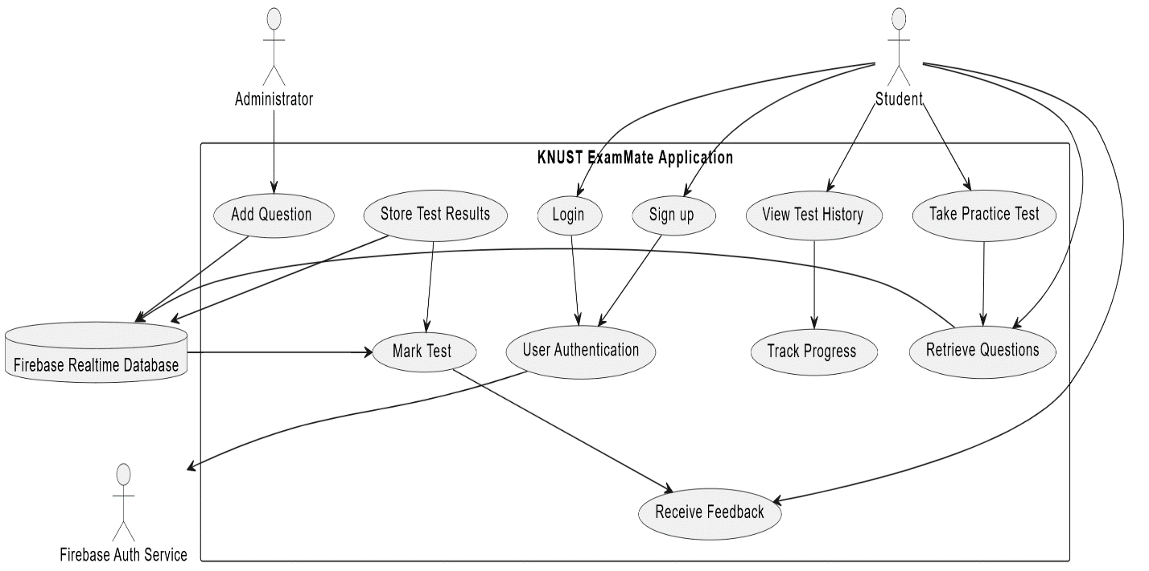

Figure 2 - Use Case Diagram of System

Use Case Descriptions

* Actor: Student (Stu)
* The primary user of the application who interacts with various features to enhance their exam preparation.
* Actor: Administrator (Admin)
* The individuals responsible for developing and maintaining the application.
* Actor: Firebase Realtime Database (DB)
* The back-end service used to store and manage data, such as questions, test results, and user details.
* Actor: Firebase Auth Service (au)
* The service used for authenticating users.
* **Use Case: User Authentication (UC1)**
* Actor: Firebase Auth Service
* Description: The system uses Firebase Auth Service to validate user credentials during sign-up and login. Upon successful validation, access is granted to the user's account.
* **Use Case: Take Practice Test (UC2)**
* Actor: Student
* Description: The student selects a course and starts a practice test. The system retrieves relevant questions from the database and presents them to the student. The student answers each question within a set time limit.
* Relationships:
* Student --> Take Practice Test
* Take Practice Test --> Retrieve Questions
* **Use Case: View Test History (UC3)**
* Actor: Student
* Description: The student can view a list of their past tests along with the scores and dates. This helps the student keep track of their progress over time.
* Relationships:
* Student --> View Test History
* View Test History --> Track Progress
* **Use Case: Receive Feedback (UC4)**
* Actor: Student
* Description: After completing a test, the student receives instant feedback on their performance. The system highlights correct and incorrect answers and provides explanations if available.
* Relationships:
* Student --> Receive Feedback
* Mark Test --> Receive Feedback
* **Use Case: Track Progress (UC5)**
* Actor: System
* Description: The student can view a summary of their performance across different tests and courses. This includes overall scores, improvements, and areas that need more practice.
* Relationships:
* View Test History --> Track Progress
* **Use Case: Add Question (UC6)**
* Actor: Administrator
* Description: The administrator adds new questions and their respective answers to the Firebase Realtime Database. This ensures the database is up-to-date with the latest questions for various courses.
* Relationships:
* Administrator --> Add Question
* Add Question --> Firebase Realtime Database
* **Use Case: Retrieve Questions (UC7)**
* Actor: System
* Description: The system retrieves questions from the Firebase Realtime Database based on the selected course and presents them to the student during a practice test.
* Relationships:
* Student --> Retrieve Questions
* Take Practice Test --> Retrieve Questions
* Retrieve Questions --> Firebase Realtime Database
* **Use Case: Store Test Results (UC8)**
* Actor: System
* Description: The system stores the student's test results in the Firebase Realtime Database after a test is completed. This data is used for generating feedback and tracking progress.
* Relationships:
* Store Test Results --> Firebase Realtime Database
* Store Test Results --> Mark Test
* **Use Case: Mark Test (UC9)**
* Actor: System
* Description: The system evaluates the student's answers against the stored answers in the database, calculates the score, and generates feedback.
* Relationships:
* Firebase Realtime Database --> Mark Test
* Store Test Results --> Mark Test
* **Use Case: Sign up (UC10)**
* Actor: Student
* Description: The student registers for a new account using their credentials. The system uses Firebase Auth Service to create a new user account and stores the user details.
* Relationships:
* Student --> Sign up
* Sign up --> User Authentication
* **Use Case: Login (UC11)**
* Actor: Student
* Description: The student logs in to their existing account using their credentials. The system uses Firebase Auth Service to authenticate the user and grants access to their account.
* Relationships:
* Student --> Login
* Login --> User Authentication

### 3.5.2 Activity Diagram

The diagram provided (Figure 3) offers a detailed representation of the user flow within the KNUST ExamMate application. It outlines the steps a user follows from entering their credentials to receiving feedback on their practice tests. The process begins with the user entering their credentials, which are then authenticated. If the login is successful, the user can proceed to select a course. Depending on whether a course is selected, the user can either retrieve questions and answer them or view their test history and track their progress. After answering questions, the user submits the test, which then stores the test results, marks the test, and finally provides feedback to the user. If the login is unsuccessful, an error message is displayed, and the user is prompted to re-enter their credentials. This diagram efficiently captures the primary functionalities and decision points within the application, ensuring a clear understanding of the user experience and the flow of actions within the KNUST ExamMate system.

Figure 3 - Activity Diagram

### 3.5.3 Sequence Diagram

The diagram provided below (Figure 4) illustrates the interaction between various components and actors within the KNUST ExamMate system, detailing the process flow for both students and administrators. The diagram begins with a student signing up or logging in, where the credentials are validated by the Firebase Authentication Service. Upon successful login, the student can select a course, retrieve questions from the Firebase Realtime Database, and answer them. After submitting the test, the results are stored, marked, and feedback is provided. The student can then view their test history and track their progress, with the system displaying relevant data from the database.

In the event of an unsuccessful login, an error message is displayed. Additionally, administrators can add new questions to the system, which involves updating the questions in the Firebase Realtime Database and confirming the update. This sequence diagram effectively captures the dynamic interactions and the flow of information between users, the Firebase services, and the KNUST ExamMate system, highlighting both the front-end and back-end processes involved in delivering a seamless user experience.

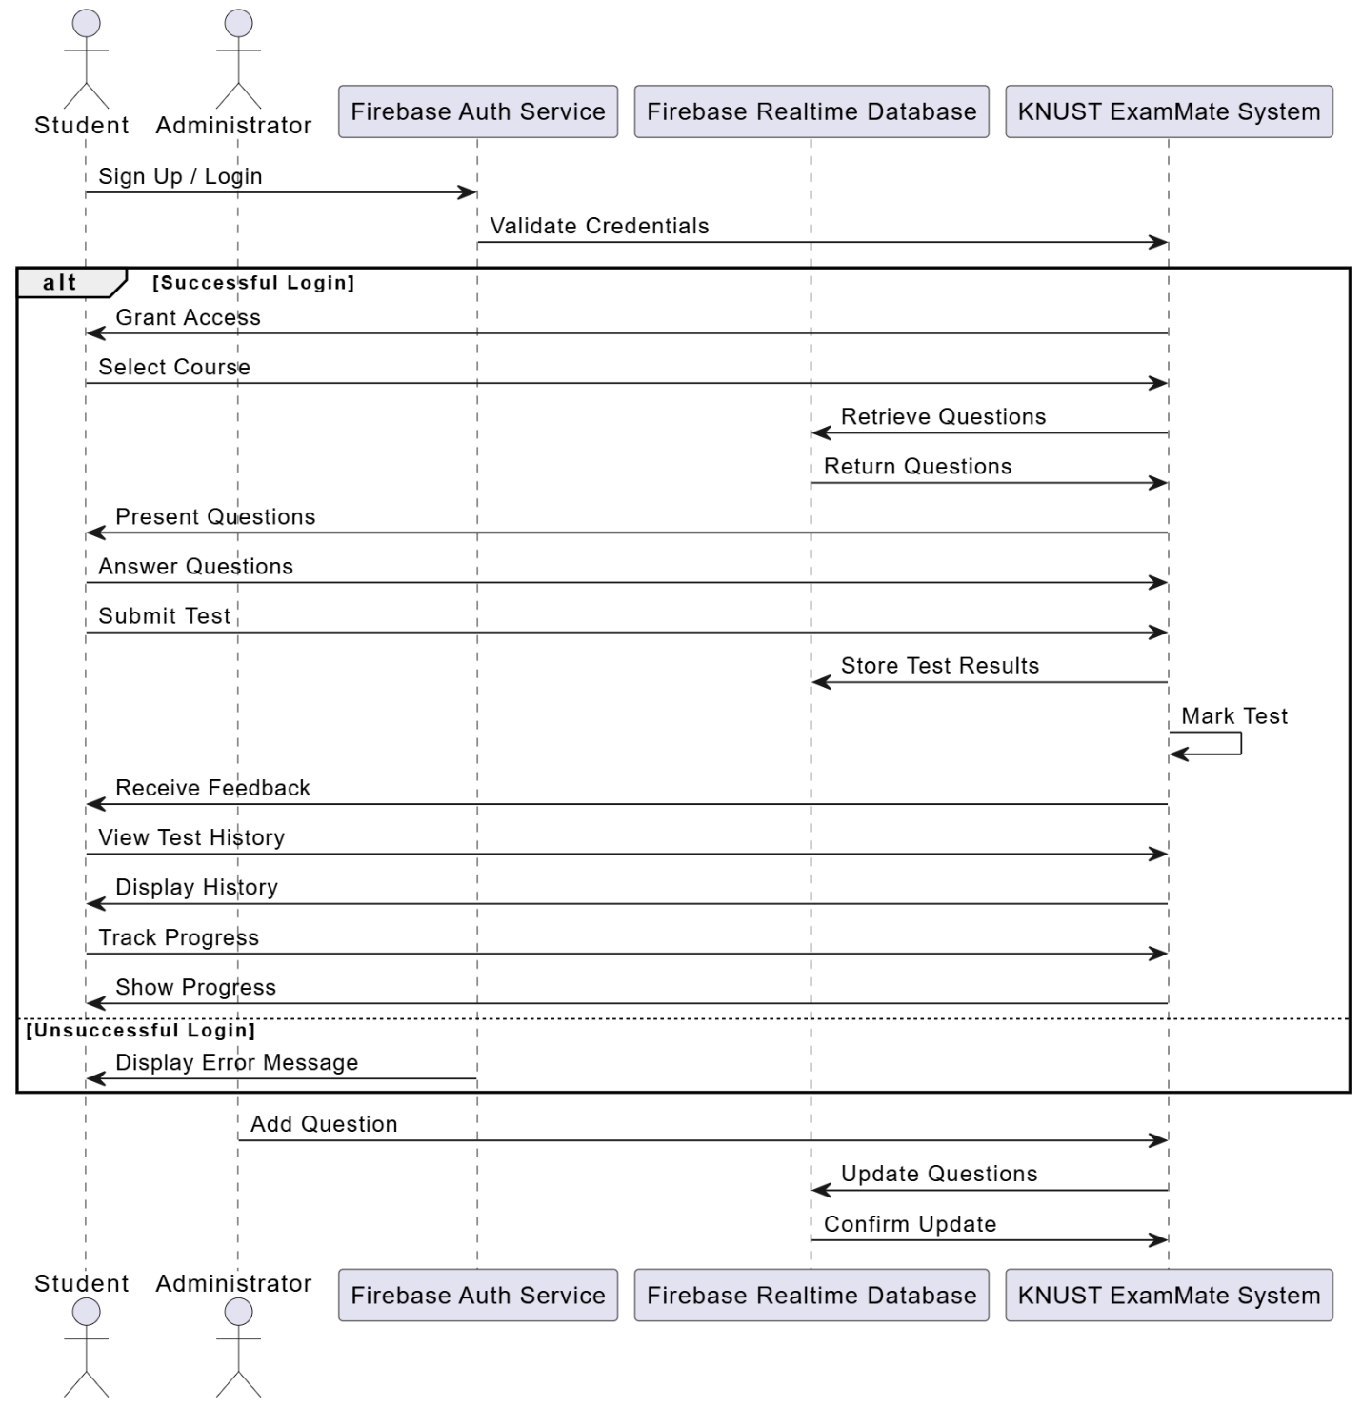

Figure 4 - Sequence Diagram

### 3.5.4 Class Diagram

The class diagram below (Figure 5) provides a comprehensive overview of the structure and relationships between the various classes in the KNUST ExamMate system. The primary classes involved are Student, Administrator, Test, Question, Course, FirebaseAuthService, and FirebaseRealtimeDatabase.

* **Student**:

This class includes attributes such as `studentID`, `name`, `email`, `password`, and `testHistory`. It contains methods for `register()`, `login()`, `viewTestHistory()`, and `takeTest()`. Each student can take multiple tests, as represented by the relationship between Student and Test.

* **Administrator:**

This class includes attributes such as `adminID`, `name`, `email`, and `password`. It contains methods for `login()`, `addQuestion()`, and `manageQuestions()`. Administrators can add and manage questions within the system.

* **Test**:

This class includes attributes such as `testID`, `studentID`, `course`, `questions`, `answers`, `score`, and `feedback`. It contains methods for `startTest()`, `submitTest()`, `calculateScore()`, and `generateFeedback()`. Tests consist of multiple questions, which are linked to the Question class.

* **Question**:

This class includes attributes such as `questionID`, `course`, `title`, `options`, and `correctAnswer`. It contains a method for `validateAnswer()`. Questions are stored in the Firebase Realtime Database and are associated with courses and tests.

* **Course**:

This class includes attributes such as `courseID`, `courseName`, and `questions`. It contains a method for `getQuestions()`. Courses contain multiple questions relevant to their subject matter.

* **FirebaseAuthService**:

This class includes attributes such as `authURL` and methods for `authenticateUser()` and `createUser()`. It handles user authentication processes.

* **FirebaseRealtimeDatabase**:

This class includes attributes such as `databaseURL` and methods for `storeQuestion()`, `retrieveQuestion()`, `storeTestResult()`, and `retrieveTestResult()`. It manages the storage and retrieval of questions and test results.

The relationships between these classes highlight how students and administrators interact with the system. Students use the FirebaseAuthService for authentication and interact with the Test class to take exams. Tests are comprised of questions retrieved from the Firebase Realtime Database. Administrators manage questions and courses, ensuring the question bank is up-to-date and relevant. This class diagram effectively encapsulates the structural design and interactions within the KNUST ExamMate system, providing a clear blueprint for the system's architecture.

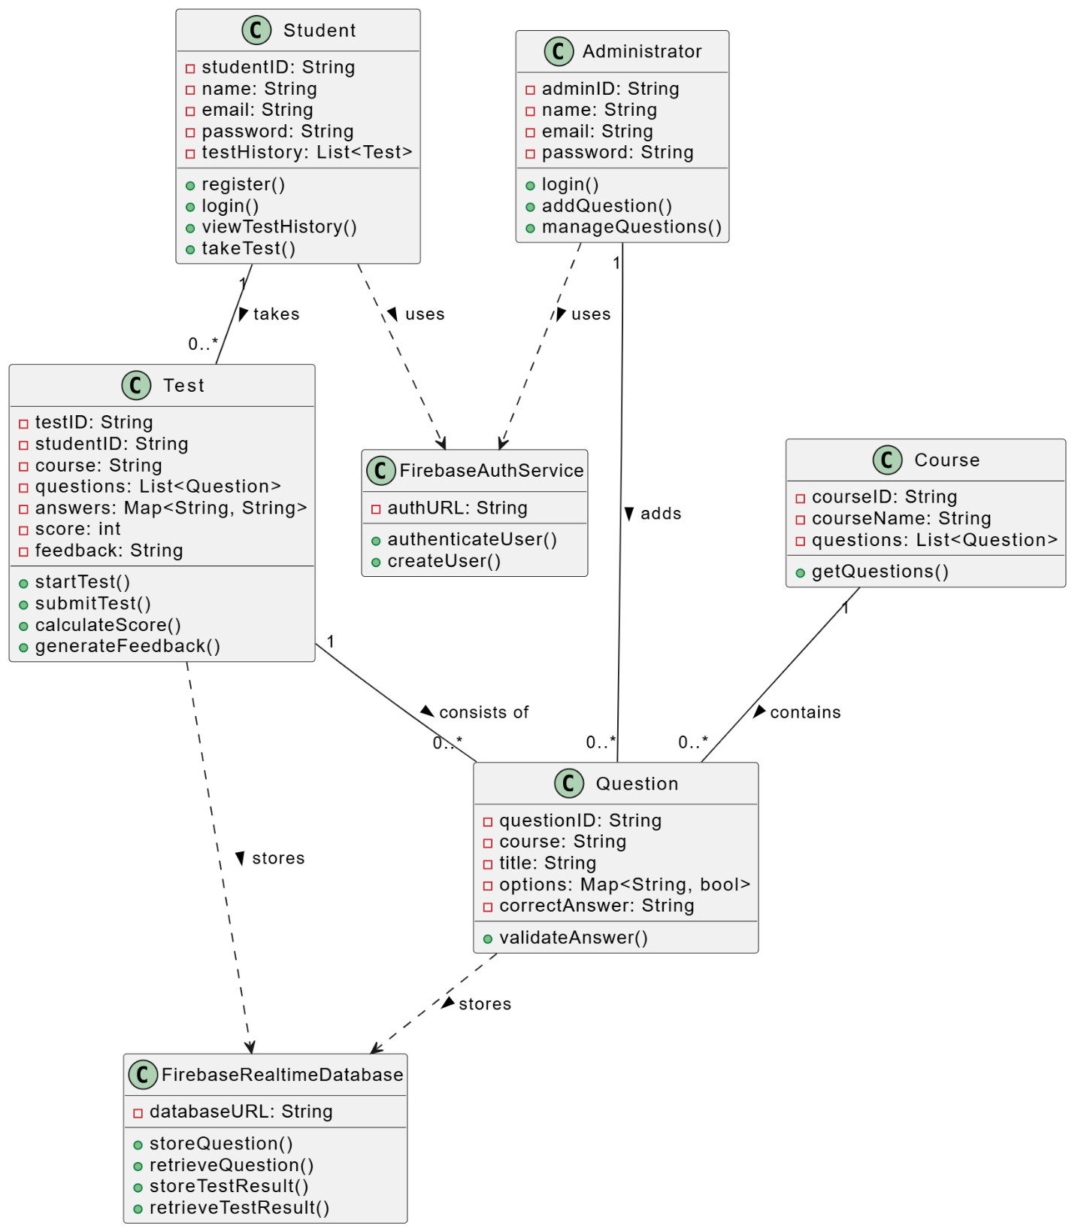

Figure 5 - Class Diagram

## 3.6 Non-Functional Requirements

* Performance:
* The application should ensure minimal latency in loading questions and providing feedback.
* Timed tests should be precise, and the timer must be accurate.
* Scalability:
* The backend system must be scalable to accommodate a growing number of users and exam questions.
* Firebase Realtime Database should be efficiently utilized to manage large datasets.
* Security:
* User data, including authentication credentials and test results, must be securely stored and managed.
* The application should follow best practices for data security and privacy.
* Usability:
* The user interface should be designed to be intuitive and accessible, ensuring a positive user experience.
* Instructions and feedback should be clear and helpful.
* Reliability:
* The application should be reliable, with minimal downtime or errors.
* It should handle network issues gracefully and provide meaningful error messages.
* Compatibility:
* The application must be compatible with both Android and iOS platforms.
* It should work on a range of devices with varying screen sizes and resolutions.
* Maintainability:
* The application’s codebase should be well-documented and organized for ease of maintenance and future enhancements.
* Regular updates and bug fixes should be manageable without significant disruptions.

## 3.7 Security Concepts

Security is a paramount concern in the development of the KNUST ExamMate application, given the sensitive nature of the data it handles. The system stores personal information, test questions, answers, and student performance data, which require robust security measures to ensure confidentiality, integrity, and availability. The following security concepts are implemented to address potential security issues:

* **Authentication:**

Firebase Authentication is used to securely authenticate users (both students and administrators). Users must register with valid email addresses and passwords, which are securely stored and managed by Firebase Auth Service. During login, user credentials are verified against those stored in Firebase, ensuring that only authorized individuals gain access to the application.

* **Data Encryption:**
* Encryption at Rest:

All sensitive data, including user information and test results, is encrypted at rest in Firebase Realtime Database. This prevents unauthorized access to data even if the storage is compromised.

* Encryption in Transit:

All data transmitted between the client application and Firebase servers is encrypted using HTTPS. This ensures that data cannot be intercepted or tampered with during transmission.

* **Data Integrity:**

To ensure the integrity of the data, Firebase provides mechanisms to detect and prevent unauthorized modifications. Firebase Realtime Database rules are used to enforce data validation and ensure that only authorized users can perform write operations on specific data nodes.

* **User Data Privacy:**

User data privacy is maintained by implementing strict access controls and ensuring that personal information is only accessible to the authenticated user. Firebase Authentication handles user credentials, ensuring that passwords are securely hashed and not stored in plain text.

* **Regular Security Audits and Monitoring:**

Regular security audits are conducted to identify and address potential vulnerabilities in the application. Firebase provides real-time monitoring and alerting features to detect and respond to suspicious activities promptly.

## 3.8 Project Methods

The KNUST ExamMate application was developed using a combination of Agile and Plan-Driven methodologies to ensure a balanced and effective development process. This hybrid approach leveraged the strengths of both methodologies to deliver a high-quality product while maintaining flexibility and structure throughout the development lifecycle.

**Agile Methodology**

* Iterative Development:
* The project was divided into multiple iterations or sprints, each focusing on a specific set of features or components.
* This iterative approach allowed for regular assessment and improvement of the application based on feedback and changing requirements.
* Continuous Feedback:
* Regular feedback sessions were conducted with stakeholders(students and Supervisor), to gather insights and suggestions.
* This feedback was incorporated into subsequent iterations, ensuring the application met user needs and expectations.
* Flexibility and Adaptability:
* The Agile methodology provided the flexibility to adapt to changes in requirements or priorities.
* This adaptability was crucial in addressing new insights or challenges that emerged during development.

**Plan-Driven Methodology**

* Comprehensive Planning:
* Detailed planning was conducted at the beginning of the project to outline the scope, objectives, and deliverables.
* A project timeline was established, with milestones and deadlines to ensure timely completion of each phase.
* Documentation:
* Extensive documentation was created to capture requirements, design specifications, and project plans.
* This documentation provided a clear reference for the development team and stakeholders, ensuring alignment and clarity.

## 3.9 The Various Software Process Models

Software process models, also known as software development life cycle models, are systematic approaches used to plan, design, build, and maintain software applications. These models provide a structured framework that guides the development team through various stages of the software development process. Different software process models exist, each with its unique characteristics, advantages, and limitations. Some common software process models include:

* **Waterfall Model**:

The Waterfall model is a linear and sequential approach where each phase of the software development life cycle must be completed before moving on to the next phase. It follows a top-down approach, starting with requirements gathering, followed by design, implementation, testing, and maintenance. Once a phase is completed, it is challenging to revisit it. The Waterfall model is suitable for projects with well-defined and stable requirements.

* **Iterative Model**:

The Iterative model involves cyclic repetition of the development process, with each cycle refining and expanding on the previous one. It allows for progressive refinement of the software through multiple iterations. Each iteration results in a working product increment. This model is suitable when requirements are subject to change or not entirely clear at the beginning of the project.

* **Incremental Model**:

The Incremental model divides the development process into smaller, manageable parts called increments. Each increment represents a functional piece of the software and is developed separately. Incremental development allows for early delivery of essential features and facilitates user feedback at various stages.

* **Spiral Model**:

The Spiral model combines the iterative nature of prototyping with the controlled and systematic aspects of the Waterfall model. It involves cycles of planning, risk analysis, engineering, and evaluation, making it particularly suitable for projects with high-risk factors or evolving requirements.

* **Agile Model**:

Agile is an umbrella term that encompasses several iterative and incremental software development methodologies, such as Scrum, Kanban, and Extreme Programming (XP). Agile methodologies emphasize collaboration, customer feedback, and delivering functional software frequently. The Agile approach is well-suited for projects with rapidly changing requirements and where early and continuous delivery of valuable software is critical.

* **V-Model (Validation and Verification Model)**:

The V-Model is an extension of the Waterfall model that emphasizes the importance of testing and validation at each stage of the development process. The left side of the V represents the development phases, while the right side represents the corresponding testing and validation phases.

* **Big Bang Model**:

In the Big Bang model, there is no formal planning or specific development process. Development starts abruptly, and the requirements are gathered as the project progresses. This model is suitable for small and simple projects with a limited budget and timeline.

## 3.10 Project Model and Justification

The chosen model for the KNUST ExamMate project is a Hybrid Model, which integrates the flexibility and iterative nature of Agile with the structured planning and documentation of Plan-Driven methodologies. This hybrid approach enables adaptive planning, evolutionary development, and continuous improvement while ensuring early delivery of functional components. By blending these methodologies, the project benefits from the ability to respond to changes and user feedback promptly, while also maintaining a clear project scope, timeline, and comprehensive documentation. This balanced approach facilitates a structured yet flexible development process, ensuring that the project stays on track and meets its objectives effectively.

### 3.10.1 Justification for Chosen Model

* **Flexibility and Adaptability**:

The hybrid model allows the development team to adapt to changes and new requirements swiftly, which is essential for a project like KNUST ExamMate, where user feedback and evolving needs are crucial.

* **Continuous Feedback and Improvement**:

By incorporating Agile principles, the project benefits from continuous user feedback, allowing for regular assessment and improvement. This ensures that the final product meets the users' expectations and needs.

* **Structured Planning and Documentation**:

The Plan-Driven aspects provide a solid foundation for the project with detailed planning, risk management, and extensive documentation. This structure ensures that the project stays on track and aligns with the defined goals and timelines.

* **Balanced Approach:**

The hybrid model leverages the strengths of both Agile and Plan-Driven methodologies, providing a balanced approach that addresses the complexities and dynamic nature of the project while ensuring quality and reliability.

* **Risk Management**:

The iterative nature of the hybrid model allows for early identification and mitigation of risks, reducing the likelihood of significant issues arising late in the development process.

* **Efficient Resource Utilization**:

By planning tasks and iterations effectively, the hybrid model ensures efficient use of resources, optimizing the team's productivity and the project's overall efficiency.

The hybrid model was chosen for the KNUST ExamMate project due to its ability to combine the adaptability and user-centric approach of Agile with the detailed planning and structure of Plan-Driven methodologies. This approach ensures that the project can handle evolving requirements and user feedback while maintaining a clear and organized development process, ultimately delivering a high-quality application tailored to the needs of KNUST students.

## 3.11 Project Design and Consideration

The design of the KNUST ExamMate application focuses on creating an intuitive, user-friendly interface that enhances the student experience. The project employs the Flutter framework, chosen for its capability to provide responsive and visually appealing designs across multiple platforms. The design process began with prototyping and wireframing, ensuring that the layout and navigation are clear and logical.

### 3.11.1 User Interface Design

The user interface (UI) design of the KNUST ExamMate application includes several key screens, each tailored to facilitate specific functionalities for students and administrators:

* Sign Up Page: Allows new users to register by entering their personal details and credentials.
* Login Page: Enables returning users to access their accounts securely.
* Colleges Page: Displays a list of colleges, helping users to navigate and select their respective colleges.
* Programs Page: Shows various programs offered, allowing users to choose the program they are enrolled in.
* Courses Page: Lists all the courses available, from which users can select the course they want to take practice tests in.
* Start Test Page: Initiates the practice test process, letting users begin their selected test.
* Test Page: Displays the test questions and options for answering, including a timer for timed tests.
* Score Page: Shows the test results, including the score and a summary of performance.
* Review Answers Page: Allows users to review their answers and see explanations for correct and incorrect responses.
* Test History Page: Provides a history of all tests taken by the user, showing scores and dates.
* Profile Page: Displays user profile information and allows for profile management.
* About Page: Contains information about the application, its purpose, and developers.

Each screen is designed to be visually consistent, maintaining a cohesive look and feel throughout the application. The focus is on simplicity and ease of use, ensuring that users can navigate the app effortlessly and perform tasks efficiently.

By integrating these design considerations, the KNUST ExamMate application aims to provide a seamless and enjoyable user experience, facilitating effective exam preparation for students.

Below are the diagrams that illustrate the user interfaces for KNUST ExamMate:

|  |  |  |
| --- | --- | --- |
| A screen shot of a phone  Description automatically generated  Figure 6 - Sign Up Page | A screen shot of a phone  Description automatically generated  Figure 7 - Login Page | A screen shot of a cell phone  Description automatically generated  Figure 8 - Colleges Page |
| Figure 9 - Programs Page | A screenshot of a cell phone  Description automatically generated  Figure 10 - Courses Page | A screenshot of a test  Description automatically generated  Figure 11 - Start Test Page |
| Figure 12 - Test Page | Figure 13 - Score Page | A screenshot of a cell phone  Description automatically generated  Figure 14 - Review Answers Page |
| Figure 15 - Test History Page | Figure 16 - Profile Page | A screen shot of a cell phone  Description automatically generated  Figure 17 - About Page |

### 3.10.2 Database Design

The database design for the KNUST ExamMate application forms the backbone of the system, providing a structured and efficient way to manage and retrieve data. This design is essential for ensuring the seamless operation of the application, enabling functionalities such as user management, test creation, question storage, and performance tracking. The schema comprises several interconnected tables, each serving a specific purpose and interacting through well-defined relationships. Here is a detailed description of the schema for the KNUST ExamMate application:

**Tables and Columns:**

* Users Table
* userID (Primary Key)
* username
* email
* password
* Questions Table
* questionID (Primary Key)
  + questionText
  + options
  + correctAnswer
  + courseID (Foreign Key)
* Courses Table
* courseID (Primary Key)
* courseName
* Tests Table
* testID (Primary Key)
* userID (Foreign Key)
* courseID (Foreign Key)
* TestHistory Table
* historyID (Primary Key)
* testID (Foreign Key)
* userID (Foreign Key)
* testScore
* answers (Stored as JSON)

**Relationships:**

* The Users table is linked to the Tests table via userID.
* The Courses table is linked to the Questions table via courseID.
* The Tests table is linked to the TestHistory table via testID and to the Courses table via courseID.

The diagram below (Figure 18) is the Entity-Relationship Diagram (ERD), for the KNUST ExamMate application. It visually represents the structure of the database and the relationships between its various entities. This diagram is a crucial component of the database design, illustrating how data is organized and interconnected within the system. The ERD highlights key entities such as Users, Courses, Questions, Tests, and TestHistory, and shows how they interact through primary and foreign key relationships. This visual representation provides a clear and concise overview of the database schema, ensuring a robust and efficient data management framework for the application. By depicting the relationships between tables, the ERD helps in understanding the flow of data and supports the development of a well-structured and scalable application.

Figure 18 - Entity Relationship Diagram

### 3.10.3 Development Tools

In Chapter 2, we outlined the various tools and technologies used in the development of the KNUST ExamMate application. Here in Chapter 3, we provide a more detailed description of how each tool was utilized in the development process.

* Flutter
* **Description:** Flutter is an open-source UI software development toolkit created by Google. It is used for building natively compiled applications for mobile, web, and desktop from a single codebase.
* Usage:
* **UI Design:** Flutter was primarily used to design the user interface of the KNUST ExamMate application. Its rich set of pre-designed widgets allowed for the creation of a visually appealing and user-friendly interface.
* **State Management:** The provider package in Flutter was used to manage the state of the application. This helped in efficiently updating the UI in response to user actions and changes in data.
* **Navigation:** Flutter's navigation and routing capabilities were employed to enable smooth transitions between different screens of the application, such as the login screen, test-taking screen, and test history screen.
* **Testing:** Flutter's built-in testing framework was used to write unit tests, widget tests, and integration tests to ensure the reliability and performance of the application.
* Firebase
* **Description:** Firebase is a platform developed by Google for creating mobile and web applications. It provides a variety of tools and services to help developers build high-quality apps, including real-time databases, authentication, and analytics.
* Usage:
* **Firebase Realtime Database:** Used to store and manage the exam questions, test results, and test history. The real-time capabilities of the database ensured that data updates were instantly reflected in the application.
* **Firebase Authentication:** Used to handle user authentication, including user sign-up, login, and password management. This ensured secure access to the application.
* **Firebase Analytics:** Implemented to track user interactions and gather insights into how users engage with the application. This data was used to improve the user experience.
* Dart
* **Description:** Dart is the programming language used to write Flutter applications. It is optimized for building user interfaces with features that support sound type checking and efficient asynchronous programming.
* Usage:
* **Application Logic:** Dart was used to write the core logic of the application, including managing the timer for practice tests, calculating test scores, and implementing the feedback system.
* **Integration with Firebase:** Dart's HTTP package was used to interact with Firebase services, such as sending requests to the Realtime Database and handling authentication processes.
* **Error Handling:** Robust error handling mechanisms were implemented in Dart to ensure the application could gracefully handle any issues, such as network errors or data retrieval problems.
* Android Studio:
* **Description:** Android Studio was the primary integrated development environment (IDE) used for developing the KNUST ExamMate application.
* Usage:
  + **Flutter Development:** Android Studio provided extensive support for Flutter development, allowing us to build, test, and debug the mobile application efficiently. We utilized its powerful editor to write Dart code and design the user interface with Flutter's widget framework.
  + **Emulators:** The built-in emulators in Android Studio were essential for testing the application on various virtual devices, ensuring compatibility and performance across different Android versions and device configurations.
  + **Plugins:** Various plugins, such as the Flutter and Dart plugins, were installed to enhance productivity by providing features like code completion, syntax highlighting, and debugging tools.
* Git and GitHub
* **Description:** Git is a distributed version control system used to track changes in source code during software development. GitHub is a web-based platform that uses Git for version control and provides hosting for software development projects.
* Usage:
* **Version Control:** Git was used to keep track of changes made to the codebase, allowing for collaborative development between team members. Branches were created for different features, and changes were merged into the main branch after thorough testing.
* **Project Management:** GitHub was used to host the repository, manage issues, and track progress. The GitHub Issues feature was utilized to document and address bugs, feature requests, and other tasks.
* **Collaboration:** Pull requests and code reviews on GitHub ensured that the code was reviewed and approved by us before being merged into the main branch, maintaining code quality and consistency.

# Chapter 4: Implementation and Results

## 4.1 Chapter Overview

This chapter details the implementation and results of the KNUST ExamMate system. It outlines the process of mapping the logical design onto the physical platform, providing algorithms for implementing the user interface (UI) and database development, supported by flowchart diagrams. The construction section includes snippet codes that showcase the system logic and screenshots of the developed system to illustrate its functionality.

In the testing section, a comprehensive testing plan is presented, covering both component and system testing. The component testing includes algorithms for testing the UI and database to ensure each part functions correctly. System testing encompasses verification and validation testing algorithms to confirm that the system meets all specified requirements and performs as expected in real-world scenarios.

Finally, the results section presents the outcomes of the implementation and testing phases, demonstrating the effectiveness and reliability of the KNUST ExamMate system. This chapter provides a thorough examination of the development process, from design to deployment, highlighting the critical steps and methodologies employed to achieve a successful implementation.

## 4.2 Mapping Logical Design onto Physical Platform

The process of mapping the logical design onto the physical platform involves translating the abstract, conceptual framework of the KNUST ExamMate system into a concrete, operational system. This entails implementing the user interface (UI) and the database according to the designed architecture. The following sections detail the algorithms and flowcharts used to guide this implementation.

### 4.2.1 Implementing the User Interface

The implementation of the user interface (UI) algorithm for the KNUST ExamMate system focuses on creating an intuitive, user-friendly interface that facilitates seamless interaction for students. The UI is developed using the Flutter framework, leveraging its rich widget library and responsive design capabilities to ensure a consistent experience across various devices. This section outlines the step-by-step process for translating the logical design of the UI into a fully functional, interactive application, covering the initialization of the project, design and development of key screens, and optimization for responsiveness and usability.

1. **Initialize Flutter Project**: Set up the Flutter development environment and create a new Flutter project.
2. **Design UI Layouts**: Sketch wireframes for each screen (Registration, Login, Home, Practice Test, Feedback, Progress Tracking) and use Flutter widgets to build these layouts.
3. **Develop Registration and Login Screens**: Create forms for user input and implement Firebase Authentication for secure sign-up and login.
4. **Build Home Screen**: Design the dashboard layout and add navigation to different sections such as Programs page, Test page, Profile page .
5. **Implement Practice Test Screen**: Create a dynamic test-taking environment with a timer and question navigation.
6. **Develop Feedback Screen**: Display test results with correct and incorrect answers and provide detailed explanations for each question.
7. **Create Progress Tracking Screen**: Display historical test data with latest test appearing first.
8. **Ensure Responsiveness**: Test the UI on different screen sizes and resolutions and optimize layouts for both Android and iOS devices.
9. **Finalize and Test UI**: Perform usability testing and make necessary adjustments based on feedback.

The following flowchart diagram illustrates the step-by-step process for implementing the user interface (UI) of the KNUST ExamMate system, from project initialization to final testing and optimization.

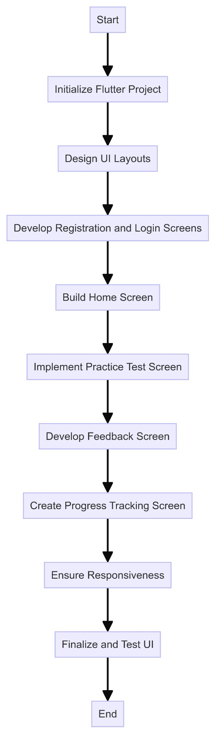

Figure 19 - Flowchart Diagram for Implementing the User Interface (UI) of the KNUST ExamMate

### 4.2.2 Implementing the Database

The implementation of the database algorithm for the KNUST ExamMate system focuses on establishing a robust and efficient backend to manage and synchronize all necessary data in real-time. Using Firebase Realtime Database, this process ensures secure storage and accessibility of user profiles, exam questions, test results, and progress tracking data. This section outlines the step-by-step procedure for setting up the database, defining the data structure, implementing data management functions, and optimizing performance to support the seamless operation of the KNUST ExamMate system.

1. **Set Up Firebase Project**: Create a Firebase project in the Firebase Console and configure authentication and database settings.
2. **Define Data Structure**: Design the database schema to store user profiles, questions, test results, and progress data.
3. **Implement User Data Management**: Create functions to add, update, and retrieve user profiles securely.
4. **Develop Question Bank Management**: Implement methods to store and retrieve exam questions and categorize them by course and topic.
5. **Set Up Real-Time Data Sync**: Enable real-time synchronization for test results and progress tracking to reflect data changes immediately.
6. **Optimize Database Performance**: Index key fields to improve query performance and implement data validation rules to maintain data integrity.
7. **Test Database Functionality**: Perform unit tests on data management functions to ensure data consistency and reliability.

The following flowchart diagram illustrates the step-by-step process for implementing the database of the KNUST ExamMate system, from setting up the Firebase project to testing database functionality.

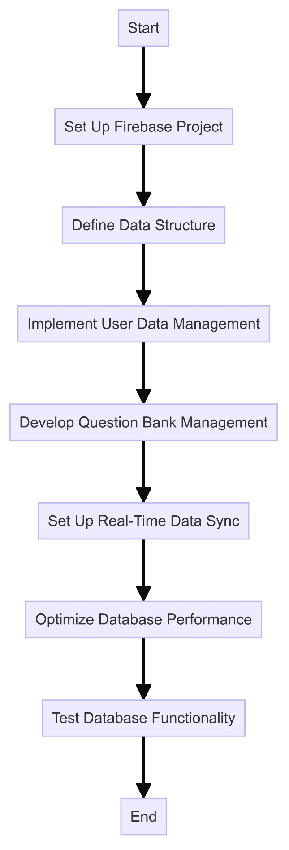

Figure 20 - Flowchart Diagram for Implementing the Database of the KNUST ExamMate System

Fig Y – Flowchart Diagram for Implementing the Database of the KNUST ExamMate System

The implementation of the KNUST ExamMate system meticulously translates the logical design into a fully functional application by focusing on both the user interface and database components. Through the use of the Flutter framework for the UI and Firebase Realtime Database for backend management, the system ensures a seamless, responsive, and secure experience for users. The step-by-step algorithms and accompanying flowcharts provide a clear roadmap for developing each component, highlighting the systematic approach taken to achieve the project goals. This comprehensive implementation lays a solid foundation for the subsequent testing phase, ensuring that all features operate smoothly and meet the intended requirements.

## 4.3 Construction

The figure below shows the code snippet for the sign-up view.

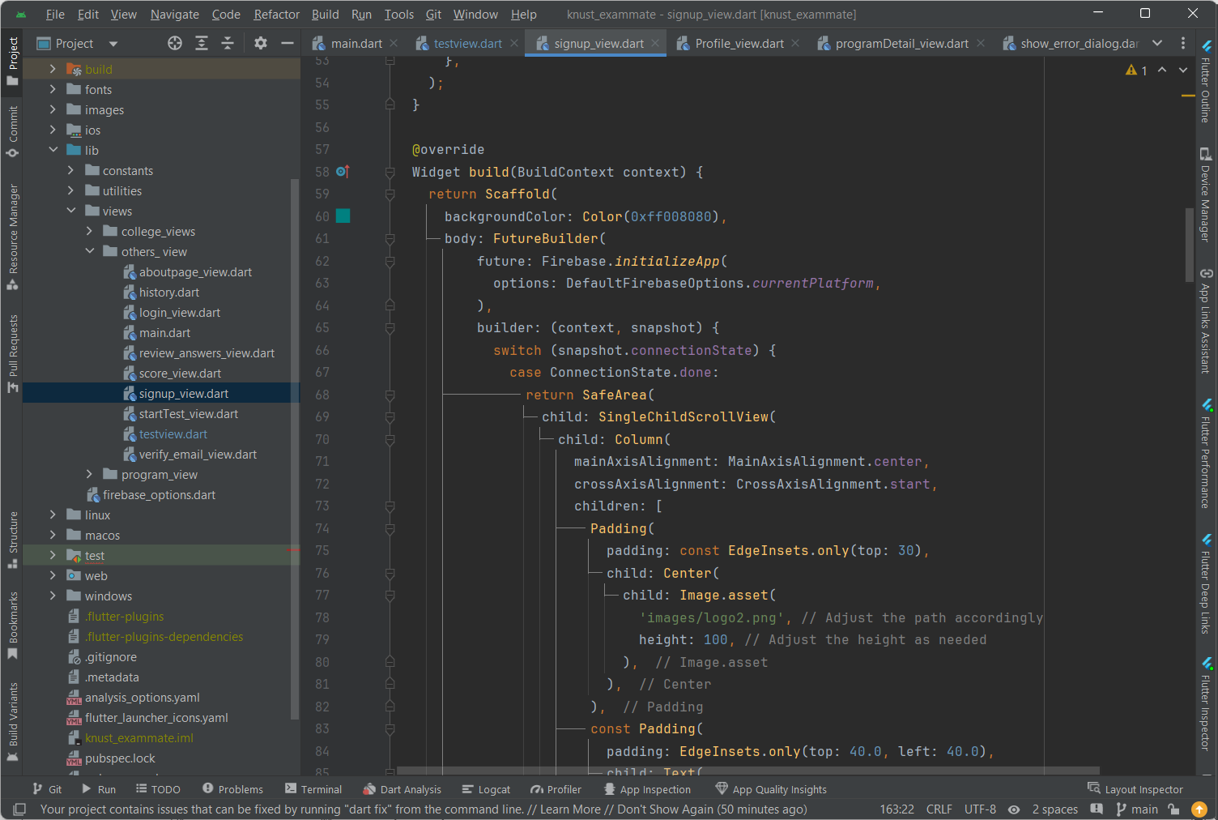

Figure 21 - Code Snippet of Sign-up View

The figure below shows the code snippet for the colleges view.

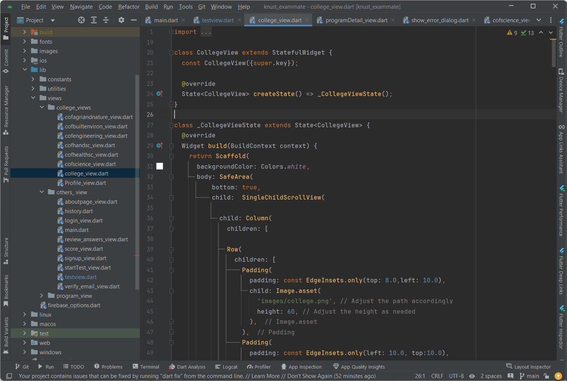

Figure 22 - Code Snippet of Colleges View

The Figure below shows the code snippet for the profile view.

Figure 23 - Code Snippet of Profile View

The figure below shows the code snippet for the test view

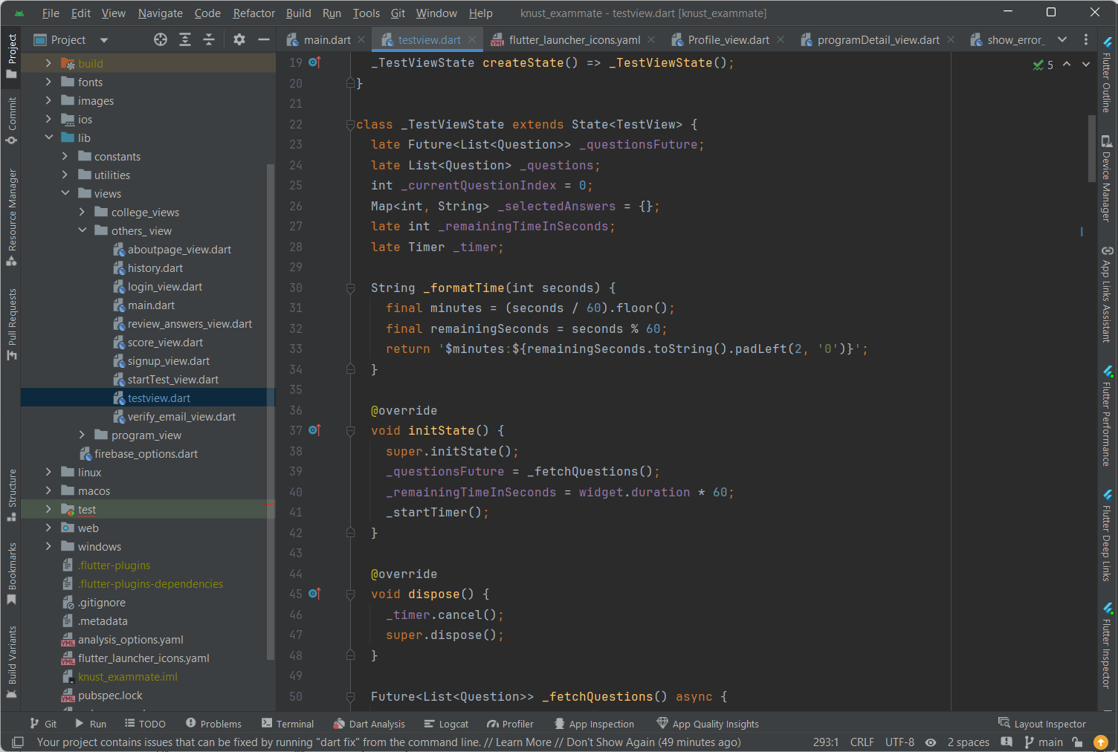

Figure 24 - Code Snippet of Test View

The figure below shows the code snippet for connecting to the database.

Figure 25 - Code Snippet for Database Connect

The figure below shows the code snippet for the score view.

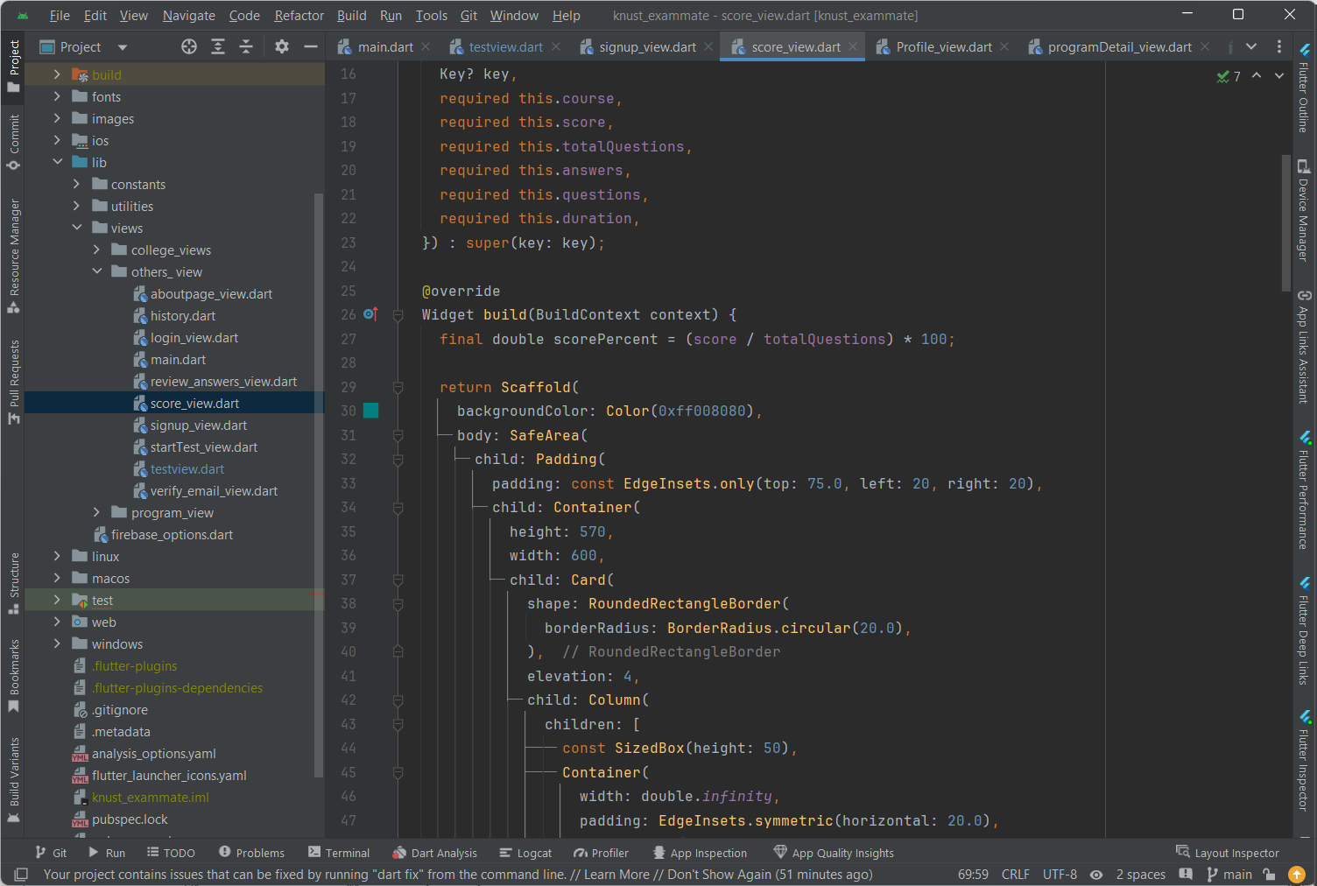

Figure 26 - Code Snippet of Score View

## 4.4 Testing

The Testing section is a crucial phase in the development of the KNUST ExamMate system, designed to ensure that every aspect of the system functions correctly and meets all specified requirements. This section outlines the comprehensive methodologies and rigorous processes used to verify and validate both the individual components and the overall performance of the system. Through systematic and thorough testing, the KNUST ExamMate system is assessed for functionality, reliability, and user experience, ensuring that it delivers a seamless and effective exam preparation tool for students at KNUST.

### 4.4.1 Testing Plan

The testing plan is meticulously divided into two main parts: components testing and system testing. Each part includes detailed algorithms to ensure that every aspect of the system is scrutinized and validated.

### 4.4.2 Components Testing

Component testing is a crucial phase in the development of the KNUST ExamMate system, ensuring that each individual component functions correctly and reliably. This section outlines the algorithms used for testing each component, focusing on verifying their performance and integration within the system.

#### 4.4.2.1 Algorithm for Testing the User Interface (UI)

The following algorithm outlines the step-by-step process for testing the User Interface (UI) of the KNUST ExamMate system to ensure it is intuitive, user-friendly, and functions correctly.

1. **Initialize Testing Environment**: Set up the Flutter testing framework and ensure all necessary dependencies are installed.
2. **Test Sign up Screen**: Enter valid and invalid data into the sign-up form. Verify that valid data is accepted and stored in the Firebase Realtime Database, and invalid data prompts appropriate error messages.
3. **Test Login Screen**: Enter valid and invalid credentials. Verify that valid credentials allow access to the application and invalid credentials prompt appropriate error messages.
4. **Test Home Screen**: Navigate to the home screen and check that links to different sections (Practice Test, Start screen, Feedback, Progress, Test History) work correctly and notifications are displayed accurately.
5. **Test Practice Test Screen**: Select subjects and topics, start a test, and submit answers. Verify that the timer functions correctly and the UI updates dynamically.
6. **Test Feedback Screen**: Complete a test and review the feedback screen. Verify that it displays correct and incorrect answers, provides explanations, and highlights areas for improvement.
7. **Test Progress Tracking Screen**: Review the progress tracking screen. Verify that it displays a detailed test history with their scores and the last taken test appearing first in that order
8. **Usability Testing**: Conduct usability testing with real users to gather feedback on the UI’s intuitiveness and ease of use. Make necessary adjustments based on feedback.

#### 4.4.2.2 Algorithm for Testing the Authentication Service

The following algorithm outlines the steps for testing the Authentication Service in the KNUST ExamMate system to ensure secure user access and data management.

1. **Initialize Testing Environment**: Set up Firebase Authentication in the testing environment and ensure all necessary dependencies are installed.
2. **Test User Registration**: Create a new user account and verify that the credentials are stored correctly in Firebase Authentication.
3. **Test User Login**: Log in with the registered user credentials. Verify that the login process is successful, and the user is authenticated.
4. **Test Invalid Login**: Attempt to log in with incorrect credentials and verify that the system prevents access and provides an error message.
5. **Test Password Recovery**: Initiate a password recovery request and verify that the recovery process works and allows the user to reset their password securely.
6. **Security Testing**: Verify that user data is encrypted and protected from unauthorized access.

#### 4.4.2.3 Algorithm for Testing the Real-Time Database

The following algorithm outlines the steps for testing the Real-Time Database component of the KNUST ExamMate system, ensuring accurate data storage, retrieval, and real-time synchronization.

1. **Initialize Testing Environment**: Set up Firebase Realtime Database in the testing environment and ensure test data is isolated from production data.
2. **Test User Data Management**: Register a user and verify that the data is stored correctly. Retrieve, update, and delete user data to ensure these operations work as expected.
3. **Test Question Bank Management**: Add, retrieve, and categorize exam questions by course . Verify that the questions can be accurately retrieved for practice tests.
4. **Test Real-Time Synchronization**: Make changes to test results and verify that these changes are immediately reflected across the application.
5. **Performance Testing**: Simulate multiple concurrent users to test the database’s performance under load and verify it can handle many requests without performance degradation.
6. **Security Testing**: Ensure all data is encrypted and protected from unauthorized access and verify that access controls are enforced correctly.

#### 4.4.2.4 Algorithm for Testing the Feedback System

The following algorithm outlines the steps for testing the feedback system of the KNUST ExamMate system, ensuring it provides accurate, immediate, and detailed feedback to users after each test.

1. **Initialize Testing Environment**: Ensure that the system is set up to provide feedback after test completion.
2. **Complete a Test**: Take a practice test and submit answers.
3. **Verify Feedback Accuracy**: Check that the feedback screen displays the correct and incorrect answers accurately, provides detailed explanations, and highlights areas for improvement.
4. **Check Real-Time Feedback**: Ensure that feedback is provided immediately after test submission.
5. **Usability Testing**: Ensure that the feedback interface is intuitive and easy to understand.

#### 4.4.2.5 Algorithm for Testing the Progress Tracking

The following algorithm outlines the steps for testing the Progress Tracking component of the KNUST ExamMate system, ensuring it accurately records and displays user performance over time.

1. **Initialize Testing Environment**: Ensure that the progress tracking system is set up and connected to the database.
2. **Complete Multiple Tests**: Take several practice tests to generate data.
3. **Verify Test History Accuracy**: Check that the test history displays detailed results, including scores.
4. **Usability Testing**: Ensure that the progress tracking interface is intuitive and provides clear and actionable insights.

By following these algorithms, the components of the KNUST ExamMate system can be thoroughly tested to ensure they operate correctly and provide a seamless, reliable user experience.

### 4.4.3 System Testing

System testing evaluates the integrated system to ensure all components work together correctly and meet the specified requirements. This includes both verification and validation testing. The algorithms used for verification testing and validation testing are as follows.

#### 4.4.3.1 Algorithm for Verification Testing

1. **Initialize System Environment**: Set up the integrated system environment, ensuring all components are connected and configured correctly.
2. **Conduct Integration Testing**: Verify that each component interacts correctly with others. This includes ensuring data flows seamlessly between the UI, Authentication Service, Real-Time Database, Feedback System, and Progress Tracking.
3. **Perform End-to-End Testing**: Simulate user workflows to test the system from start to finish. This involves registering a user, logging in, taking a practice test, receiving feedback, and tracking progress.
4. **Check Data Consistency**: Verify that data remains consistent across different components. Ensure that user data, test results, and progress information are accurately stored and retrieved.
5. **Test Error Handling**: Ensure the system handles errors gracefully. Simulate different error scenarios, such as invalid inputs, network failures, and unauthorized access, to verify the system's robustness.
6. **Load Testing**: Simulate multiple concurrent users to test the system's performance under load. Ensure the system can handle a large number of requests without performance degradation.
7. **Security Testing**: Verify that security measures are in place and functioning correctly. Ensure data encryption, secure access controls, and protection against common vulnerabilities.
8. **Log and Report Issues**: Document any issues found during testing and report them to the development team for resolution.
9. **Retest After Fixes**: Once issues are fixed, retest the system to ensure the fixes are effective and no new issues have been introduced.

#### 4.4.3.2 Algorithm for Validation Testing

1. **Define Test Scenarios**: Develop realistic test scenarios based on user requirements and expected use cases, covering all major functionalities of the system.
2. **Set Up Real-World Environment**: Configure the testing environment to closely resemble the real-world deployment environment.
3. **Execute Test Scenarios**: Run the defined test scenarios, simulating real-world usage including user registration, login, taking practice tests, receiving feedback, and tracking progress.
4. **Collect User Feedback**: Gather feedback from test users to validate the system's usability and effectiveness, ensuring it meets user expectations and provides a satisfactory experience.
5. **Verify Requirements Compliance**: Ensure the system meets all specified requirements, including functional requirements (such as user registration and test-taking) and non-functional requirements (such as performance, security, and usability).
6. **Validate Data Accuracy**: Confirm that all data processed by the system is accurate, including user data, test results, feedback, and progress tracking information.
7. **Test System Reliability**: Verify that the system operates reliably over an extended period, ensuring there are no crashes, data losses, or other issues during prolonged use.
8. **Performance Validation**: Validate that the system performs well under expected load conditions, ensuring response times, data processing, and user interactions are within acceptable limits.
9. **Documentation and Reporting**: Document the results of the validation testing, reporting any issues or discrepancies found, and providing recommendations for improvement.
10. **Final Approval**: Obtain final approval from stakeholders, confirming that the system is ready for deployment and meets all necessary criteria.

By following these algorithms, the KNUST ExamMate system is thoroughly tested to ensure it provides a reliable, functional, and user-friendly experience, meeting all specified requirements and performing well in real-world scenarios.

## 4.5 Results

The Results sub-chapter presents the findings from the implementation and testing phases of the KNUST ExamMate system. This section highlights the effectiveness and reliability of the system, demonstrating how it meets the specified requirements and performs in real-world scenarios. The results are categorized into component testing results, system testing results, user feedback, and performance metrics, providing a comprehensive overview of the system’s performance and user satisfaction.

### **4.5.1 Component Testing Results**

The component testing phase ensured that each individual component of the KNUST ExamMate system functions correctly. Key outcomes include:

* **User Interface (UI)**: All screens and interactive elements were tested and confirmed to function as intended, providing a seamless user experience.
* **Authentication Service**: User registration, login, and password recovery processes were tested for accuracy and security.
* **Real-Time Database**: CRUD operations and real-time synchronization were tested to ensure data consistency and reliability.
* **Feedback System**: Immediate and detailed feedback was provided accurately after each test.
* **Progress Tracking**: The system accurately tracked and displayed user performance on test taken over time on the Test History page.

### **4.5.2 System Testing Results**

System testing evaluated the integrated system to ensure all components work together correctly. Key outcomes include:

* **Verification Testing**: Ensured that data flows seamlessly between components, with no issues in component interactions.
* **Validation Testing**: Confirmed that the system meets all specified requirements and performs well in real-world scenarios. User feedback validated the system’s usability and effectiveness.

### 4.5.3 User Feedback

During the testing phase, feedback was collected from users to validate the system’s usability and overall user experience. Key feedback points include:

* **Ease of Use**: Users found the interface intuitive and easy to navigate.
* **Functionality**: Users appreciated the comprehensive question bank, immediate feedback, and progress tracking feature.
* **Performance**: The system performed reliably without crashes or data loss, even under load conditions.

### 4.5.4 Performance Metrics

Performance testing provided insights into the system’s ability to handle multiple concurrent users and maintain responsive operation. Key performance metrics include:

* **Response Time**: The system maintained acceptable response times under various load conditions.
* **Data Synchronization**: Real-time synchronization of data was effective and efficient.
* **Scalability**: The system demonstrated the ability to scale and handle an increasing number of users and data without performance degradation.

In conclusion, the implementation and testing phases of the KNUST ExamMate system were successful, demonstrating that the system is reliable, functional, and user-friendly. The system meets all specified requirements and provides a seamless, effective study preparation tool.

# Chapter 5: FINDINGS AND CONCLUSION

## 5.1 Chapter Overview

This chapter provides a comprehensive overview of the KNUST ExamMate system's development journey, encapsulating the key findings derived from both the implementation and rigorous testing phases. It aims to present a holistic view of the project's outcomes, reflecting on the system's achievements, reliability, and user satisfaction. Additionally, this chapter delves into the overall success of the project, offering insightful conclusions based on empirical evidence. Finally, it addresses the challenges and limitations encountered during the development process, providing a candid assessment of areas that require improvement and future work considerations.

## 5.2 Findings

The findings from the KNUST ExamMate system are a culmination of extensive development and meticulous testing. These findings shed light on the system’s functionality, performance, and user reception, offering a detailed analysis of what was achieved and how well the system meets its intended objectives. The following points summarize the critical aspects uncovered during the project:

* **Implementation Success**: The system was effectively developed using the Flutter framework for the user interface and Firebase Realtime Database for backend management. The step-by-step algorithms and flowcharts facilitated a smooth transition from design to deployment.
* **User Interface**: The UI was designed to be intuitive and user-friendly, which was confirmed through usability testing. Key screens such as Sign up, Login, Home, Practice Test, Feedback, and Progress Tracking were successfully implemented and optimized for responsiveness.
* **Database Management**: The Firebase Realtime Database provided a robust backend solution, ensuring real-time data synchronization, secure storage, and efficient data retrieval. The implementation included well-structured data management functions for user profiles, exam questions, test results, and progress tracking.
* **Testing Results**: Comprehensive testing, including component and system testing, validated the functionality, reliability, and performance of the system. Usability testing gathered positive feedback from users, confirming that the system meets their needs and expectations.
* **Performance Metrics**: The system demonstrated the ability to handle multiple concurrent users without significant performance degradation. Response times remained within acceptable limits, and real-time data synchronization was efficient.

## 5.3 Conclusions

In summarizing the outcomes of the KNUST ExamMate system, several key conclusions can be drawn. This section distills the essence of the project's success, examining the reliability, user satisfaction, and scalability of the system. It also reflects on how well the system met its objectives and the extent to which it provided value to its users. These conclusions are pivotal for understanding the overall impact of the project and guiding future enhancements:

* **System Reliability**: The system is reliable and meets the specified requirements. It provides a seamless and effective user experience, facilitating students' exam preparation.
* **User Satisfaction**: Positive feedback from users indicates a high level of satisfaction with the system's functionality and ease of use.
* **Scalability and Performance**: The system's architecture supports scalability, and performance testing has shown that it can handle increased user load without significant issues.

## 5.4 Challenges/Limitations of the System

While the KNUST ExamMate system has proven to be an effective and reliable tool for students, challenges and limitations were encountered during its development and implementation. These challenges highlight areas where the system can be further improved to enhance its overall functionality and user experience. Addressing these limitations is crucial for ensuring the system's continued success and scalability. The key challenges and limitations include:

* **Device Compatibility**: Minor issues were reported on certain devices, indicating the need for further optimization to ensure a consistent experience across all platforms.
* **Long-term Scalability**: While initial scalability tests were positive, the system's performance under a significantly larger user base requires ongoing monitoring and optimization.
* **Feature Scope**: The current version focuses on core functionalities. Expanding the feature set to include personalized study plans, social learning tools, and advanced analytics could further enhance the system's value.
* **Time Constraints**: Due to time constraints, only questions for certain courses were completed. Expanding the question bank to cover more courses is necessary to provide a comprehensive exam preparation tool.
* **Continuous Improvement**: Regular updates and improvements are necessary to keep the system relevant and address any emerging issues or user feedback.

## 5.5 Lessons Learnt

The development and implementation of the KNUST ExamMate system have provided numerous valuable insights and lessons. This section reflects on these learnings, which span technical, operational, and user experience domains. These lessons will serve as a guide for future projects and contribute to the ongoing improvement of the KNUST ExamMate system.

### 5.5.1 Technical Insights

The technical phase of the KNUST ExamMate project underscored the critical importance of early prototyping, the efficient use of Firebase, and the challenges of designing a responsive user interface. Each of these technical aspects provided key learnings that will inform and enhance future development processes.

* **Importance of Early Prototyping**

The early prototyping phase proved critical in identifying potential design and functionality issues. Creating wireframes and mockups before diving into full development helped clarify the project's scope and provided a visual guide, significantly reducing the need for major revisions later.

* **Efficient Use of Firebase**

Utilizing Firebase Realtime Database for backend management was a pivotal decision. However, understanding the full capabilities and limitations of Firebase was essential. Effective data structuring and efficient querying were vital to maintaining performance and ensuring real-time data synchronization.

* **Responsive Design Challenges**

Designing a responsive user interface that works seamlessly across various devices required careful planning and testing. Adopting Flutter facilitated this process due to its robust support for responsive design, but it also highlighted the importance of continuous device compatibility testing.

### 5.5.2 Operational Insights

The development of the KNUST ExamMate project highlighted several crucial operational insights. Working collaboratively underscored the importance of clear communication and effective version control, facilitated by tools like Git and GitHub. These practices were essential for maintaining coherence and quality throughout the project. Time management emerged as a critical challenge, emphasizing the need for realistic timelines and prioritization of core functionalities. Incorporating user feedback throughout the development process proved invaluable, providing critical insights into user needs and preferences, and facilitating timely adjustments and enhancements. Establishing a continuous feedback loop will be essential for ongoing system improvements.

* **Collaborative Development**

Working with a partner on the project emphasized the importance of clear communication and version control. Using Git and GitHub streamlined collaboration, allowing for efficient code integration and conflict resolution. Regular updates and code reviews were crucial in maintaining project coherence and quality.

* **Time Management**

Time constraints posed significant challenges, particularly in expanding the question bank and implementing additional features. This experience underscored the need for realistic project timelines and prioritization of core functionalities. Future projects will benefit from more detailed project planning and time allocation.

* **User Feedback Integration**

Incorporating user feedback throughout the development process was invaluable. Usability testing sessions provided critical insights into user needs and preferences, allowing for timely adjustments and enhancements. Establishing a continuous feedback loop with users will remain a priority for ongoing system improvements.

### 5.5.3 User Experience Insights

User experience (UX) was a central focus in the KNUST ExamMate project, with a user-centered design approach being fundamental to its success. Prioritizing intuitive navigation, clear visuals, and straightforward functionality ensured a positive user experience. Future enhancements will continue to emphasize user-centered design principles to maintain and improve user satisfaction. Managing user data securely and efficiently was also crucial, with Firebase Authentication playing a key role in securing user login and data protection. Scalability considerations highlighted the importance of anticipating future growth, ensuring that the system can accommodate an increasing user base without performance degradation through ongoing optimization and robust architecture planning.

* **User-Centered Design**

A user-centered approach was fundamental to the project's success. Prioritizing intuitive navigation, clear visuals, and straightforward functionality ensured a positive user experience. Future enhancements will continue to focus on user-centered design principles to maintain and improve user satisfaction.

* **Handling User Data**

Managing user data securely and efficiently was a critical aspect of the project. Leveraging Firebase Authentication ensured secure user login and data protection. Understanding and implementing best practices for data privacy and security will remain a key focus in future developments.

* **Scalability Considerations**

While the system demonstrated initial scalability, anticipating and planning for future growth was a significant learning point. Ensuring the system can handle an increasing user base without performance degradation requires ongoing optimization and robust architecture planning.

## 5.6 Recommendations for future works

The KNUST ExamMate system has laid a solid foundation, but there are several areas where further enhancements and new features could significantly improve its functionality, usability, and overall value. This section outlines key recommendations for future work, aimed at addressing current limitations, expanding capabilities, and ensuring the system remains relevant and effective.

### 5.6.1 Expanding the Question Bank

* **Comprehensive Coverage**

Expanding the question bank to include a wider range of courses and subjects is essential. This will provide more comprehensive exam preparation tools for students across different faculties and disciplines.

* **Collaboration with Educators**

Engaging with educators and academic departments can help in curating high-quality questions that align with the curriculum. This collaboration can also facilitate the inclusion of up-to-date and relevant exam materials.

* **Diverse Question Types**

Incorporating a variety of question types, such as multiple-choice, short answer, and essay questions, can enhance the learning experience. This diversity can better simulate actual exam conditions and provide a more well-rounded preparation tool.

### 5.6.2 Enhancing User Features

* **Personalized Study Plans**

Introducing personalized study plans based on user performance and learning goals can significantly improve the system's value. These plans can adapt to the user's strengths and weaknesses, providing targeted practice and recommendations.

* **Social Learning Tools**

Incorporating social learning features, such as discussion forums, peer reviews, and study groups, can foster a collaborative learning environment. These tools can enhance engagement and provide additional support for students.

* **Advanced Analytics**

Enhancing the analytics capabilities to include more detailed performance metrics and insights can help users better understand their progress. Advanced analytics can provide actionable feedback and identify areas needing improvement.

### 5.6.3 Improving System Performance

* **Scalability Enhancements**

Continuously monitoring and optimizing the system's performance to handle a growing user base is crucial. Implementing more robust server infrastructure and load balancing techniques can ensure smooth operation under increased demand.

* **Cross-Platform Optimization**

Further optimization for cross-platform compatibility is necessary to ensure a consistent user experience across all devices. Addressing minor compatibility issues and conducting extensive testing on various platforms will enhance reliability.

* **Offline Capabilities**

Developing offline capabilities can allow users to access certain features and study materials without an internet connection. This functionality can be particularly beneficial for students in areas with limited connectivity.

## 5.7 Recommendations for Project Commercialization

Commercializing the KNUST ExamMate system presents an exciting opportunity to reach a wider audience, generate revenue, and enhance the platform's impact on education. This section outlines strategic recommendations for successfully bringing the system to market, including potential business models, marketing strategies, and partnership opportunities.

### 5.7.1 Business Models

* **Freemium Model**

Adopt a freemium model where the basic functionalities of the KNUST ExamMate system are offered for free, while advanced features and premium content are available through a subscription plan. This approach allows users to experience the platform's value before committing to a paid plan.

* **Subscription-Based Model**

Implement a subscription-based model where users pay a monthly or annual fee to access all features of the platform. Different tiers can be offered, with higher tiers providing additional benefits such as personalized study plans, advanced analytics, and offline capabilities.

* **Institutional Licensing**

Partner with educational institutions to offer the KNUST ExamMate system on a licensing basis. Schools, colleges, and universities can purchase licenses to provide the platform to their students as part of their academic resources.

### 5.7.2 Marketing Strategies

* **Digital Marketing Campaigns**

Leverage digital marketing channels such as social media, search engine optimization (SEO), and email marketing to reach potential users. Creating engaging content, tutorials, and testimonials can showcase the system's benefits and attract new users.

* **Partnerships and Collaborations**

Collaborate with educational institutions, tutoring centers, and online learning platforms to promote the KNUST ExamMate system. These partnerships can provide access to a broader user base and enhance the platform's credibility.

* **Influencer and Community Marketing**

Engage educational influencers and online communities to endorse and promote the KNUST ExamMate system. Influencers can provide authentic reviews and recommendations, while community engagement can foster word-of-mouth marketing.

* **Free Trials and Discounts**

Offer free trials and introductory discounts to new users to encourage them to try the platform. This strategy can help convert trial users into paying customers by demonstrating the platform's value.

### 5.7.3 Enhancing User Engagement

* **Gamification**

Incorporate gamification elements such as badges, leaderboards, and rewards to enhance user engagement and motivation. Gamification can make the learning process more enjoyable and encourage users to actively participate in their exam preparation.

* **Feedback and Support**

Provide excellent customer support and gather user feedback to continuously improve the platform. Implementing a feedback loop where users can suggest features and report issues will help create a user-centric product.

* **Continuous Updates and Improvements**

Regularly update the platform with new features, content, and improvements based on user feedback and market trends. Keeping the platform fresh and relevant will retain existing users and attract new ones.

### 5.7.4 Monetization Opportunities

* **Advertising**

Consider incorporating targeted advertising within the platform. Ads can be strategically placed to ensure they do not disrupt the user experience. Partnering with relevant educational brands can provide additional revenue streams.

* **In-App Purchases**

Offer in-app purchases for supplementary resources such as study guides, video tutorials, and interactive exercises. This approach provides users with additional value while generating revenue.

* **Affiliate Programs**

Establish affiliate programs with educational content providers and other complementary platforms. Affiliates can earn commissions for referring users to the KNUST ExamMate system, creating a mutually beneficial relationship.

## 5.8 References

* Firebase. (n.d.). Firebase Realtime Database. Retrieved from <https://firebase.google.com/products/realtime-database/>
* Flutter. (n.d.). Flutter Documentation. Retrieved from <https://flutter.dev/docs>
* Quizlet. (n.d.). Features. Retrieved from <https://quizlet.com/features>
* Google Developers. (n.d.). *Firebase Authentication*. Retrieved from <https://firebase.google.com/docs/auth>
* Google Developers. (n.d.). *Flutter: Build beautiful native apps in record time*. Retrieved from <https://flutter.dev>